CEC 2005 Benchmark Function Fix Dimensions

| Comparison of optimization results for the CEC benchmark functions 2005 (Fix Dim) | | | | | | | | |
| --- | --- | --- | --- | --- | --- | --- | --- | --- |
|  | Function |  | OLOA | LOA | PSO | GA | GSA | WOA |
|  | F1 | Mean | **3.83E-75** | 1.03E+04 | 6.28E+04 | 6.60E+04 | 2.64E+03 | 1.40E-11 |
|  | Std | 1.18E-74 | 2.92E+03 | 5.24E+03 | 7.18E+03 | 7.60E+02 | 2.29E-11 |
|  | CPU | 0.192 | 0.081 | 0.092 | 0.222 | 1.266 | 0.122 |
|  | F2 | Mean | **5.28E-38** | 3.97E+01 | 4.12E+10 | 1.80E+12 | 1.09E+01 | 2.17E-08 |
|  | Std | 1.34E-37 | 1.37E+01 | 1.14E+11 | 3.04E+12 | 2.07E+00 | 3.59E-08 |
|  | CPU | 0.170 | 0.069 | 0.069 | 0.120 | 0.616 | 0.119 |
|  | F3 | Mean | **7.90E-72** | 2.25E+04 | 9.01E+04 | 1.29E+05 | 7.70E+03 | 9.09E+04 |
|  | Std | 2.50E-71 | 8.32E+03 | 9.21E+03 | 3.57E+04 | 3.32E+03 | 3.22E+04 |
|  | CPU | 0.903 | 0.275 | 0.214 | 0.286 | 0.898 | 0.277 |
|  | F4 | Mean | **6.58E-35** | 3.75E+01 | 8.76E+01 | 8.12E+01 | 2.00E+01 | 6.33E+01 |
|  | Std | 1.40E-34 | 7.56E+00 | 2.94E+00 | 3.09E+00 | 2.77E+00 | 2.88E+01 |
|  | CPU | 0.138 | 0.039 | 0.039 | 0.095 | 0.566 | 0.088 |
|  | F5 | Mean | 2.90E+01 | 6.76E+06 | 2.29E+08 | 2.53E+08 | 3.08E+05 | **2.88E+01** |
|  | Std | 2.23E-02 | 2.84E+06 | 6.37E+07 | 3.29E+07 | 2.48E+05 | 1.13E-01 |
|  | CPU | 0.269 | 0.075 | 0.069 | 0.103 | 0.678 | 0.114 |
|  | F6 | Mean | 5.77E+00 | 1.02E+04 | 5.95E+04 | 6.34E+04 | 2.61E+03 | **1.53E+00** |
|  | Std | 6.54E-01 | 1.94E+03 | 5.25E+03 | 5.51E+03 | 6.92E+02 | 4.15E-01 |
|  | CPU | 0.130 | 0.044 | 0.077 | 0.105 | 0.614 | 0.100 |
|  | F7 | Mean | 3.02E-02 | 6.18E-01 | 1.09E+02 | 9.96E+01 | 3.77E-01 | **1.87E-02** |
|  | Std | 3.65E-02 | 2.33E-01 | 2.09E+01 | 2.81E+01 | 1.75E-01 | 1.74E-02 |
|  | CPU | 0.464 | 0.113 | 0.136 | 0.169 | 0.673 | 0.175 |
|  | F8 | Mean | -3.89E+03 | -2.73E+03 | -5.26E+03 | -5.54E+03 | -2.45E+03 | **-8.59E+03** |
|  | Std | 4.59E+02 | 4.76E+02 | 5.35E+02 | 2.01E+03 | 4.33E+02 | 9.48E+02 |
|  | CPU | 0.248 | 0.105 | 0.083 | 0.134 | 0.617 | 0.088 |
|  | F9 | Mean | **0.00E+00** | 1.27E+02 | 4.08E+02 | 4.05E+02 | 6.47E+01 | 1.42E-03 |
|  | Std | 0.00E+00 | 1.48E+01 | 2.35E+01 | 3.86E+01 | 2.27E+01 | 4.48E-03 |
|  | CPU | 0.178 | 0.081 | 0.077 | 0.108 | 0.661 | 0.113 |
|  | F10 | Mean | **4.44E-16** | 1.49E+01 | 2.01E+01 | 2.04E+01 | 8.25E+00 | 4.49E-07 |
|  | Std | 0.00E+00 | 9.67E-01 | 2.11E-01 | 1.63E-01 | 8.23E-01 | 7.42E-07 |
|  | CPU | 0.203 | 0.077 | 0.088 | 0.122 | 0.705 | 0.081 |
|  | F11 | Mean | **0.00E+00** | 1.14E+02 | 5.60E+02 | 5.84E+02 | 4.30E+02 | 1.17E-01 |
|  | Std | 0.00E+00 | 2.32E+01 | 5.23E+01 | 8.12E+01 | 5.29E+01 | 2.69E-01 |
|  | CPU | 0.247 | 0.094 | 0.072 | 0.145 | 0.784 | 0.125 |
|  | F12 | Mean | 3.92E-01 | 1.86E+06 | 5.68E+08 | 5.62E+08 | 1.96E+02 | **1.65E-01** |
|  | Std | 9.54E-02 | 2.29E+06 | 1.80E+08 | 1.11E+08 | 4.55E+02 | 1.51E-01 |
|  | CPU | 0.922 | 0.298 | 0.277 | 0.358 | 0.895 | 0.397 |
|  | F13 | Mean | 2.88E+00 | 1.49E+07 | 9.69E+08 | 1.11E+09 | 4.68E+04 | **1.11E+00** |
|  | Std | 2.57E-01 | 1.38E+07 | 2.55E+08 | 2.07E+08 | 4.26E+04 | 3.68E-01 |
|  | CPU | 1.002 | 0.316 | 0.289 | 0.347 | 0.942 | 0.405 |
|  | F14 | Mean | 9.88E+00 | 1.14E+01 | **2.16E+00** | 7.80E+01 | 9.13E+00 | 3.97E+00 |
|  | Std | 3.42E+00 | 5.04E+00 | 1.50E+00 | 9.03E+01 | 5.45E+00 | 1.31E+00 |
|  | CPU | 2.289 | 0.702 | 0.534 | 0.581 | 0.922 | 0.642 |
|  | F15 | Mean | 1.65E-03 | 5.56E-03 | 5.64E-03 | 1.14E-01 | 1.94E-02 | **8.20E-04** |
|  | Std | 9.18E-04 | 7.35E-03 | 5.75E-03 | 6.62E-02 | 1.26E-02 | 6.04E-04 |
|  | CPU | 0.170 | 0.055 | 0.058 | 0.080 | 0.236 | 0.059 |
|  | F16 | Mean | -1.03E+00 | -1.03E+00 | -1.01E+00 | 8.15E-01 | **-1.03E+00** | -1.03E+00 |
|  | Std | 2.52E-03 | 2.32E-04 | 3.22E-02 | 1.53E+00 | 2.56E-16 | 2.22E-05 |
|  | CPU | 0.150 | 0.039 | 0.039 | 0.084 | 0.159 | 0.048 |
|  | F17 | Mean | 4.00E-01 | 3.98E-01 | 4.03E-01 | 2.04E+00 | **3.98E-01** | 3.99E-01 |
|  | Std | 3.08E-03 | 7.87E-05 | 4.99E-03 | 9.32E-01 | 1.39E-05 | 1.20E-03 |
|  | CPU | 0.125 | 0.034 | 0.042 | 0.073 | 0.156 | 0.053 |
|  | F18 | Mean | 3.06E+00 | 3.02E+00 | 3.20E+00 | 5.43E+01 | **3.00E+00** | 3.00E+00 |
|  | Std | 1.04E-01 | 2.28E-02 | 1.81E-01 | 3.52E+01 | 1.32E-14 | 2.05E-03 |
|  | CPU | 0.114 | 0.063 | 0.048 | 0.075 | 0.116 | 0.050 |
|  | F19 | Mean | -3.78E+00 | -3.83E+00 | **-3.85E+00** | -3.77E+00 | -3.84E+00 | -3.82E+00 |
|  | Std | 5.95E-02 | 2.94E-02 | 3.07E-03 | 6.44E-02 | 1.94E-02 | 7.84E-02 |
|  | CPU | 0.173 | 0.077 | 0.050 | 0.058 | 0.209 | 0.058 |
|  | F20 | Mean | -2.67E+00 | -3.18E+00 | -2.98E+00 | -2.88E+00 | **-3.32E+00** | -3.11E+00 |
|  | Std | 3.83E-01 | 6.69E-02 | 1.82E-01 | 3.96E-01 | 2.59E-03 | 3.03E-01 |
|  | CPU | 0.181 | 0.052 | 0.070 | 0.083 | 0.238 | 0.045 |
|  | F21 | Mean | **-8.57E+00** | -7.84E+00 | -2.86E+00 | -2.09E+00 | -6.41E+00 | -6.44E+00 |
|  | Std | 9.63E-01 | 3.57E+00 | 8.60E-01 | 4.41E-01 | 3.94E+00 | 2.47E+00 |
|  | CPU | 0.252 | 0.094 | 0.059 | 0.098 | 0.252 | 0.083 |
|  | F22 | Mean | -8.91E+00 | -5.19E+00 | -2.60E+00 | -2.69E+00 | **-9.64E+00** | -6.09E+00 |
|  | Std | 1.31E+00 | 3.52E+00 | 8.25E-01 | 8.21E-01 | 2.42E+00 | 2.72E+00 |
|  | CPU | 0.306 | 0.086 | 0.080 | 0.109 | 0.250 | 0.103 |
|  | F23 | Mean | -7.89E+00 | -5.93E+00 | -2.34E+00 | -2.01E+00 | **-9.87E+00** | -5.60E+00 |
|  | Std | 1.69E+00 | 3.94E+00 | 9.28E-01 | 7.14E-01 | 2.12E+00 | 2.74E+00 |
|  | CPU | 0.367 | 0.091 | 0.092 | 0.123 | 0.245 | 0.105 |

| **P-value of the T-test analysis for the CEC benchmark functions 2005 (Fix Dim)** | | | | | | |
| --- | --- | --- | --- | --- | --- | --- |
|  | Function | OLOA versus LOA | OLOA versus PSO | OLOA versus GA | OLOA versus GSA | OLOA versus WOA |
|  | F1 | 1.59E-09 | 1.30E-18 | 1.41E-16 | 2.01E-09 | 6.98E-02 |
|  | F2 | 3.15E-08 | 2.68E-01 | 7.79E-02 | 2.38E-12 | 7.16E-02 |
|  | F3 | 9.32E-08 | 4.62E-17 | 1.16E-09 | 8.10E-07 | 5.08E-08 |
|  | F4 | 6.06E-12 | 1.04E-25 | 1.03E-24 | 9.84E-15 | 1.73E-06 |
|  | F5 | 5.70E-07 | 1.15E-09 | 3.09E-15 | 1.00E-03 | 8.02E-06 |
|  | F6 | 2.13E-12 | 3.50E-18 | 2.59E-18 | 5.82E-10 | 1.12E-12 |
|  | F7 | 3.10E-07 | 2.63E-12 | 1.55E-09 | 8.33E-06 | 3.81E-01 |
|  | F8 | 2.85E-05 | 8.74E-06 | 2.09E-02 | 1.04E-06 | 3.58E-11 |
|  | F9 | 4.71E-16 | 1.62E-21 | 1.32E-17 | 4.26E-08 | 3.31E-01 |
|  | F10 | 1.42E-20 | 8.94E-35 | 6.60E-37 | 3.02E-17 | 7.14E-02 |
|  | F11 | 6.76E-12 | 9.24E-18 | 1.02E-14 | 1.25E-15 | 1.87E-01 |
|  | F12 | 1.96E-02 | 9.11E-09 | 4.34E-12 | 1.90E-01 | 8.20E-04 |
|  | F13 | 3.12E-03 | 5.01E-10 | 1.58E-12 | 2.73E-03 | 2.79E-10 |
|  | F14 | 4.44E-01 | 3.81E-06 | 2.84E-02 | 7.18E-01 | 7.43E-05 |
|  | F15 | 1.13E-01 | 4.39E-02 | 4.32E-05 | 3.22E-04 | 2.75E-02 |
|  | F16 | 5.52E-03 | 7.10E-02 | 1.29E-03 | 3.42E-03 | 3.49E-03 |
|  | F17 | 1.91E-02 | 1.93E-01 | 2.73E-05 | 1.76E-02 | 1.30E-01 |
|  | F18 | 2.35E-01 | 5.11E-02 | 2.19E-04 | 7.72E-02 | 8.30E-02 |
|  | F19 | 1.74E-02 | 6.09E-04 | 8.93E-01 | 5.66E-03 | 2.21E-01 |
|  | F20 | 5.80E-04 | 3.47E-02 | 2.39E-01 | 4.30E-05 | 1.15E-02 |
|  | F21 | 5.42E-01 | 4.19E-11 | 1.75E-13 | 1.11E-01 | 2.08E-02 |
|  | F22 | 5.68E-03 | 1.63E-10 | 1.99E-10 | 4.16E-01 | 8.45E-03 |
|  | F23 | 1.66E-01 | 3.78E-08 | 7.27E-09 | 3.29E-02 | 3.78E-02 |

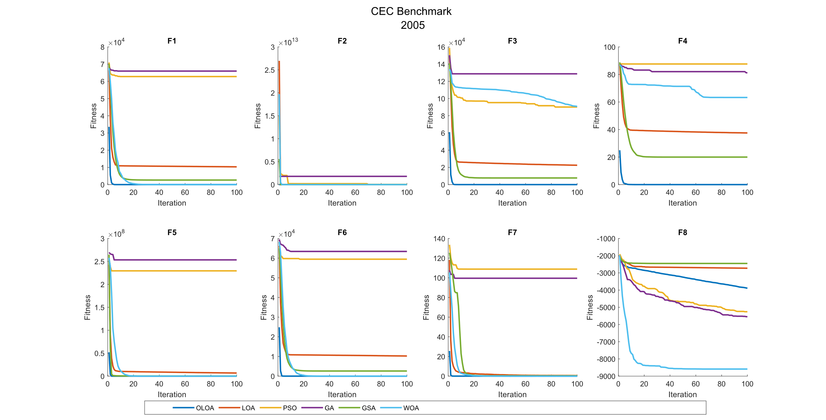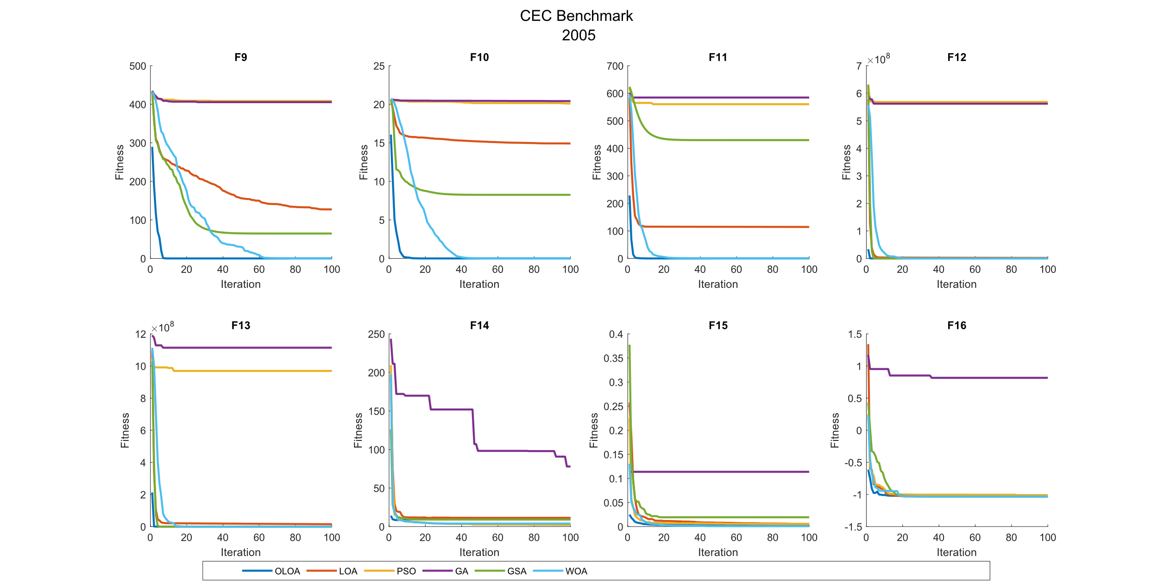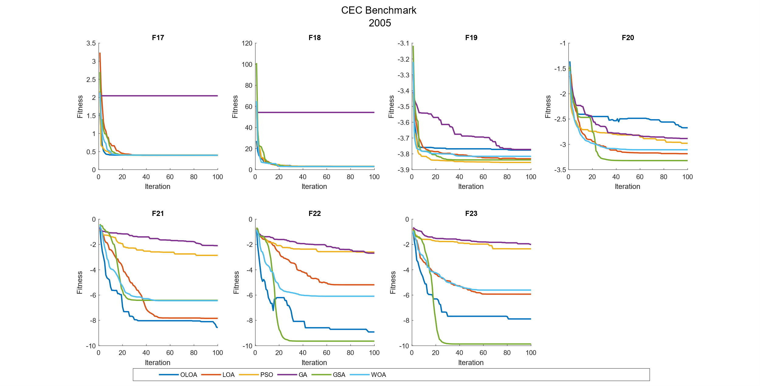

CEC 2017 Benchmark Function 10 Dimensions

| **Comparison of optimization results for the CEC benchmark functions 2017 (10 Dim)** | | | | | | | | |
| --- | --- | --- | --- | --- | --- | --- | --- | --- |
|  | Function |  | OLOA | LOA | PSO | GA | GSA | WOA |
|  | F1 | Mean | 2.91E+09 | 9.45E+09 | 4.01E+09 | 2.08E+10 | 1.52E+10 | 1.36E+09 |
|  | Std | 2.84E+09 | 3.05E+09 | 1.19E+09 | 7.19E+09 | 5.42E+09 | 1.10E+09 |
|  | CPU | 0.134 | 0.083 | 0.100 | 0.202 | 0.734 | 0.166 |
|  | F2 | Mean | The Function F2 was Delete in CEC 2017 | | | | | |
|  | Std |
|  | CPU |
|  | F3 | Mean | **7.99E+03** | 2.15E+04 | 3.93E+04 | 1.14E+06 | 2.01E+04 | 2.04E+04 |
|  | Std | 3.84E+03 | 1.28E+04 | 1.37E+04 | 2.11E+06 | 5.36E+03 | 1.77E+04 |
|  | CPU | 0.088 | 0.053 | 0.108 | 0.095 | 0.467 | 0.105 |
|  | F4 | Mean | 5.77E+02 | 1.44E+03 | 6.79E+02 | 3.67E+03 | 1.89E+03 | **5.36E+02** |
|  | Std | 1.22E+02 | 8.67E+02 | 1.11E+02 | 1.50E+03 | 7.60E+02 | 6.06E+01 |
|  | CPU | 0.045 | 0.023 | 0.067 | 0.150 | 0.466 | 0.086 |
|  | F5 | Mean | **5.46E+02** | 5.79E+02 | 5.83E+02 | 6.41E+02 | 6.19E+02 | 5.72E+02 |
|  | Std | 1.30E+01 | 1.69E+01 | 1.43E+01 | 2.40E+01 | 1.85E+01 | 1.35E+01 |
|  | CPU | 0.072 | 0.058 | 0.073 | 0.095 | 0.452 | 0.086 |
|  | F6 | Mean | 6.40E+02 | **6.38E+02** | 6.54E+02 | 6.77E+02 | 6.59E+02 | 6.48E+02 |
|  | Std | 1.15E+01 | 7.13E+00 | 9.16E+00 | 1.17E+01 | 1.07E+01 | 1.28E+01 |
|  | CPU | 0.197 | 0.059 | 0.088 | 0.122 | 0.455 | 0.095 |
|  | F7 | Mean | **7.86E+02** | 8.03E+02 | 9.95E+02 | 1.12E+03 | 8.02E+02 | 8.17E+02 |
|  | Std | 3.76E+01 | 3.34E+01 | 8.31E+01 | 9.04E+01 | 3.02E+01 | 3.11E+01 |
|  | CPU | 0.114 | 0.055 | 0.072 | 0.155 | 0.431 | 0.086 |
|  | F8 | Mean | **8.28E+02** | 8.61E+02 | 8.90E+02 | 9.14E+02 | 8.59E+02 | 8.57E+02 |
|  | Std | 8.57E+00 | 2.10E+01 | 1.63E+01 | 1.24E+01 | 6.34E+00 | 2.44E+01 |
|  | CPU | 0.084 | 0.020 | 0.070 | 0.100 | 0.478 | 0.067 |
|  | F9 | Mean | 1.44E+03 | **1.37E+03** | 2.78E+03 | 5.34E+03 | 1.81E+03 | 1.95E+03 |
|  | Std | 2.91E+02 | 1.61E+02 | 6.03E+02 | 1.55E+03 | 2.74E+02 | 5.36E+02 |
|  | CPU | 0.105 | 0.042 | 0.089 | 0.164 | 0.436 | 0.119 |
|  | F10 | Mean | 2.56E+03 | 2.67E+03 | 2.61E+03 | 3.11E+03 | 3.36E+03 | **2.54E+03** |
|  | Std | 2.47E+02 | 3.66E+02 | 2.15E+02 | 1.62E+02 | 2.77E+02 | 2.08E+02 |
|  | CPU | 0.147 | 0.050 | 0.070 | 0.091 | 0.306 | 0.094 |
|  | F11 | Mean | **1.76E+03** | 6.45E+03 | 2.44E+03 | 1.69E+04 | 7.65E+03 | 1.92E+03 |
|  | Std | 9.81E+02 | 2.61E+03 | 8.75E+02 | 9.29E+03 | 4.30E+03 | 1.06E+03 |
|  | CPU | 0.105 | 0.047 | 0.058 | 0.098 | 0.378 | 0.111 |
|  | F12 | Mean | **3.98E+06** | 4.40E+08 | 1.30E+08 | 1.84E+09 | 9.70E+08 | 1.38E+07 |
|  | Std | 9.26E+06 | 6.45E+08 | 9.07E+07 | 1.12E+09 | 7.55E+08 | 1.25E+07 |
|  | CPU | 0.067 | 0.031 | 0.080 | 0.108 | 0.391 | 0.067 |
|  | F13 | Mean | **1.03E+04** | 6.69E+05 | 1.67E+06 | 2.29E+08 | 1.03E+08 | 1.53E+04 |
|  | Std | 5.26E+03 | 1.95E+06 | 1.40E+06 | 2.71E+08 | 1.39E+08 | 7.23E+03 |
|  | CPU | 0.111 | 0.022 | 0.083 | 0.102 | 0.234 | 0.081 |
|  | F14 | Mean | 5.30E+03 | 5.87E+03 | 9.19E+03 | 3.39E+05 | 3.31E+05 | **4.22E+03** |
|  | Std | 4.37E+03 | 5.83E+03 | 8.95E+03 | 6.69E+05 | 4.49E+05 | 3.04E+03 |
|  | CPU | 0.150 | 0.033 | 0.078 | 0.095 | 0.353 | 0.084 |
|  | F15 | Mean | 2.17E+04 | **1.79E+04** | 2.45E+04 | 5.70E+05 | 3.17E+04 | 3.14E+04 |
|  | Std | 1.79E+04 | 8.89E+03 | 2.32E+04 | 6.04E+05 | 2.17E+04 | 4.53E+04 |
|  | CPU | 0.066 | 0.034 | 0.050 | 0.100 | 0.345 | 0.055 |
|  | F16 | Mean | 2.08E+03 | 2.09E+03 | **1.98E+03** | 2.55E+03 | 2.29E+03 | 2.02E+03 |
|  | Std | 1.07E+02 | 1.39E+02 | 1.88E+02 | 1.86E+02 | 1.08E+02 | 1.90E+02 |
|  | CPU | 0.113 | 0.034 | 0.058 | 0.114 | 0.308 | 0.070 |
|  | F17 | Mean | **1.80E+03** | 1.80E+03 | 1.96E+03 | 2.42E+03 | 1.96E+03 | 1.83E+03 |
|  | Std | 7.67E+01 | 3.57E+01 | 8.54E+01 | 2.91E+02 | 1.47E+02 | 5.94E+01 |
|  | CPU | 0.183 | 0.075 | 0.092 | 0.128 | 0.322 | 0.097 |
|  | F18 | Mean | **1.40E+04** | 3.40E+08 | 1.17E+06 | 6.40E+08 | 8.64E+08 | 2.61E+04 |
|  | Std | 8.89E+03 | 7.31E+08 | 6.52E+05 | 6.98E+08 | 1.38E+09 | 2.71E+04 |
|  | CPU | 0.117 | 0.023 | 0.055 | 0.102 | 0.252 | 0.056 |
|  | F19 | Mean | **3.26E+04** | 2.47E+05 | 1.66E+05 | 2.38E+07 | 6.82E+07 | 3.08E+06 |
|  | Std | 3.65E+04 | 6.72E+05 | 1.59E+05 | 2.88E+07 | 1.57E+08 | 7.99E+06 |
|  | CPU | 0.503 | 0.134 | 0.125 | 0.147 | 0.267 | 0.103 |
|  | F20 | Mean | **2.19E+03** | 2.25E+03 | 2.21E+03 | 2.46E+03 | 2.40E+03 | 2.24E+03 |
|  | Std | 9.23E+01 | 1.52E+02 | 5.27E+01 | 1.28E+02 | 1.23E+02 | 1.33E+02 |
|  | CPU | 0.075 | 0.027 | 0.038 | 0.053 | 0.128 | 0.044 |
|  | F21 | Mean | 2.34E+03 | 2.35E+03 | 2.38E+03 | 2.36E+03 | 2.43E+03 | **2.34E+03** |
|  | Std | 3.61E+01 | 3.39E+01 | 1.51E+01 | 6.47E+01 | 4.00E+01 | 4.42E+01 |
|  | CPU | 0.066 | 0.022 | 0.042 | 0.058 | 0.127 | 0.036 |
|  | F22 | Mean | 2.46E+03 | 3.07E+03 | 2.88E+03 | 3.49E+03 | 3.58E+03 | **2.41E+03** |
|  | Std | 1.50E+02 | 2.32E+02 | 2.19E+02 | 3.83E+02 | 4.66E+02 | 4.66E+01 |
|  | CPU | 0.056 | 0.028 | 0.044 | 0.045 | 0.139 | 0.048 |
|  | F23 | Mean | 2.75E+03 | 2.80E+03 | **2.68E+03** | 2.84E+03 | 2.88E+03 | 2.69E+03 |
|  | Std | 5.41E+01 | 4.35E+01 | 1.86E+01 | 6.25E+01 | 1.15E+02 | 3.35E+01 |
|  | CPU | 0.080 | 0.036 | 0.039 | 0.063 | 0.138 | 0.050 |
|  | F24 | Mean | **2.74E+03** | 2.90E+03 | 2.81E+03 | 2.94E+03 | 3.01E+03 | 2.80E+03 |
|  | Std | 1.73E+02 | 9.97E+01 | 2.62E+01 | 6.60E+01 | 1.20E+02 | 6.76E+01 |
|  | CPU | 0.080 | 0.034 | 0.048 | 0.063 | 0.147 | 0.047 |
|  | F25 | Mean | **2.98E+03** | 3.67E+03 | 3.19E+03 | 4.46E+03 | 3.70E+03 | 3.07E+03 |
|  | Std | 2.31E+01 | 2.53E+02 | 2.05E+02 | 5.65E+02 | 2.49E+02 | 2.10E+02 |
|  | CPU | 0.058 | 0.038 | 0.030 | 0.070 | 0.148 | 0.063 |
|  | F26 | Mean | 3.94E+03 | 4.15E+03 | **3.46E+03** | 4.51E+03 | 4.51E+03 | 3.96E+03 |
|  | Std | 5.81E+02 | 3.40E+02 | 4.66E+02 | 4.25E+02 | 4.38E+02 | 6.44E+02 |
|  | CPU | 0.102 | 0.039 | 0.045 | 0.064 | 0.144 | 0.055 |
|  | F27 | Mean | 3.28E+03 | 3.33E+03 | **3.14E+03** | 3.35E+03 | 3.47E+03 | 3.17E+03 |
|  | Std | 5.29E+01 | 8.73E+01 | 3.15E+01 | 6.20E+01 | 1.07E+02 | 3.11E+01 |
|  | CPU | 0.102 | 0.039 | 0.052 | 0.072 | 0.136 | 0.050 |
|  | F28 | Mean | 3.59E+03 | 3.86E+03 | **3.48E+03** | 3.89E+03 | 3.90E+03 | 3.56E+03 |
|  | Std | 1.76E+02 | 1.58E+02 | 2.11E+02 | 2.24E+02 | 1.44E+02 | 1.48E+02 |
|  | CPU | 0.089 | 0.034 | 0.044 | 0.064 | 0.139 | 0.056 |
|  | F29 | Mean | 3.40E+03 | 3.49E+03 | **3.37E+03** | 4.04E+03 | 3.85E+03 | 3.49E+03 |
|  | Std | 1.06E+02 | 1.85E+02 | 6.11E+01 | 1.87E+02 | 1.73E+02 | 2.21E+02 |
|  | CPU | 0.123 | 0.048 | 0.047 | 0.070 | 0.147 | 0.052 |
|  | F30 | Mean | 1.91E+07 | 7.47E+07 | **1.11E+06** | 8.43E+07 | 1.07E+08 | 2.97E+06 |
|  | Std | 2.21E+07 | 6.93E+07 | 6.28E+05 | 6.50E+07 | 6.53E+07 | 3.41E+06 |
|  | CPU | 0.277 | 0.088 | 0.092 | 0.105 | 0.192 | 0.102 |

|  |  |  |  |  |  |  |
| --- | --- | --- | --- | --- | --- | --- |
| **P-value of the T-test analysis for the CEC benchmark functions 2017 (10 Dim)** | | | | | | |
|  | Function | OLOA versus LOA | OLOA versus PSO | OLOA versus GA | OLOA versus GSA | OLOA versus WOA |
|  | F1 | 1.01E-04 | 2.75E-01 | 8.81E-07 | 5.74E-06 | 1.23E-01 |
|  | F2 | Deleted | | | | |
|  | F3 | 5.19E-03 | 1.69E-06 | 1.07E-01 | 1.77E-05 | 4.38E-02 |
|  | F4 | 5.97E-03 | 6.56E-02 | 3.95E-06 | 4.07E-05 | 3.58E-01 |
|  | F5 | 1.39E-04 | 1.25E-05 | 1.98E-09 | 7.42E-09 | 4.30E-04 |
|  | F6 | 7.30E-01 | 6.34E-03 | 1.24E-06 | 8.62E-04 | 1.27E-01 |
|  | F7 | 2.93E-01 | 9.78E-07 | 3.43E-09 | 2.94E-01 | 5.44E-02 |
|  | F8 | 2.22E-04 | 3.32E-09 | 4.96E-13 | 2.75E-08 | 2.26E-03 |
|  | F9 | 5.15E-01 | 5.87E-06 | 3.36E-07 | 1.00E-02 | 1.69E-02 |
|  | F10 | 4.49E-01 | 6.80E-01 | 1.35E-05 | 2.45E-06 | 8.46E-01 |
|  | F11 | 4.64E-05 | 1.21E-01 | 7.22E-05 | 5.13E-04 | 7.25E-01 |
|  | F12 | 4.64E-02 | 3.68E-04 | 6.47E-05 | 7.59E-04 | 6.22E-02 |
|  | F13 | 3.01E-01 | 1.49E-03 | 1.56E-02 | 3.08E-02 | 9.40E-02 |
|  | F14 | 8.05E-01 | 2.32E-01 | 1.32E-01 | 3.39E-02 | 5.29E-01 |
|  | F15 | 5.51E-01 | 7.69E-01 | 1.01E-02 | 2.75E-01 | 5.38E-01 |
|  | F16 | 8.60E-01 | 1.68E-01 | 1.71E-06 | 3.45E-04 | 3.76E-01 |
|  | F17 | 9.84E-01 | 3.18E-04 | 4.37E-06 | 7.96E-03 | 3.51E-01 |
|  | F18 | 1.59E-01 | 2.61E-05 | 9.49E-03 | 6.34E-02 | 1.97E-01 |
|  | F19 | 3.28E-01 | 1.83E-02 | 1.79E-02 | 1.86E-01 | 2.43E-01 |
|  | F20 | 3.16E-01 | 6.98E-01 | 3.61E-05 | 4.23E-04 | 3.84E-01 |
|  | F21 | 5.60E-01 | 2.06E-02 | 4.29E-01 | 7.77E-05 | 8.60E-01 |
|  | F22 | 1.87E-06 | 9.11E-05 | 3.24E-07 | 1.07E-06 | 3.01E-01 |
|  | F23 | 4.27E-02 | 7.55E-04 | 2.20E-03 | 3.80E-03 | 1.06E-02 |
|  | F24 | 1.80E-02 | 2.51E-01 | 2.66E-03 | 8.05E-04 | 3.47E-01 |
|  | F25 | 8.03E-08 | 5.45E-03 | 1.53E-07 | 3.41E-08 | 1.82E-01 |
|  | F26 | 3.25E-01 | 6.06E-02 | 2.20E-02 | 2.35E-02 | 9.22E-01 |
|  | F27 | 1.60E-01 | 5.65E-07 | 2.27E-02 | 1.30E-04 | 9.93E-06 |
|  | F28 | 1.87E-03 | 2.31E-01 | 3.90E-03 | 3.75E-04 | 7.11E-01 |
|  | F29 | 2.05E-01 | 4.72E-01 | 2.14E-08 | 1.18E-06 | 2.62E-01 |
|  | F30 | 2.66E-02 | 1.92E-02 | 7.65E-03 | 7.42E-04 | 3.50E-02 |

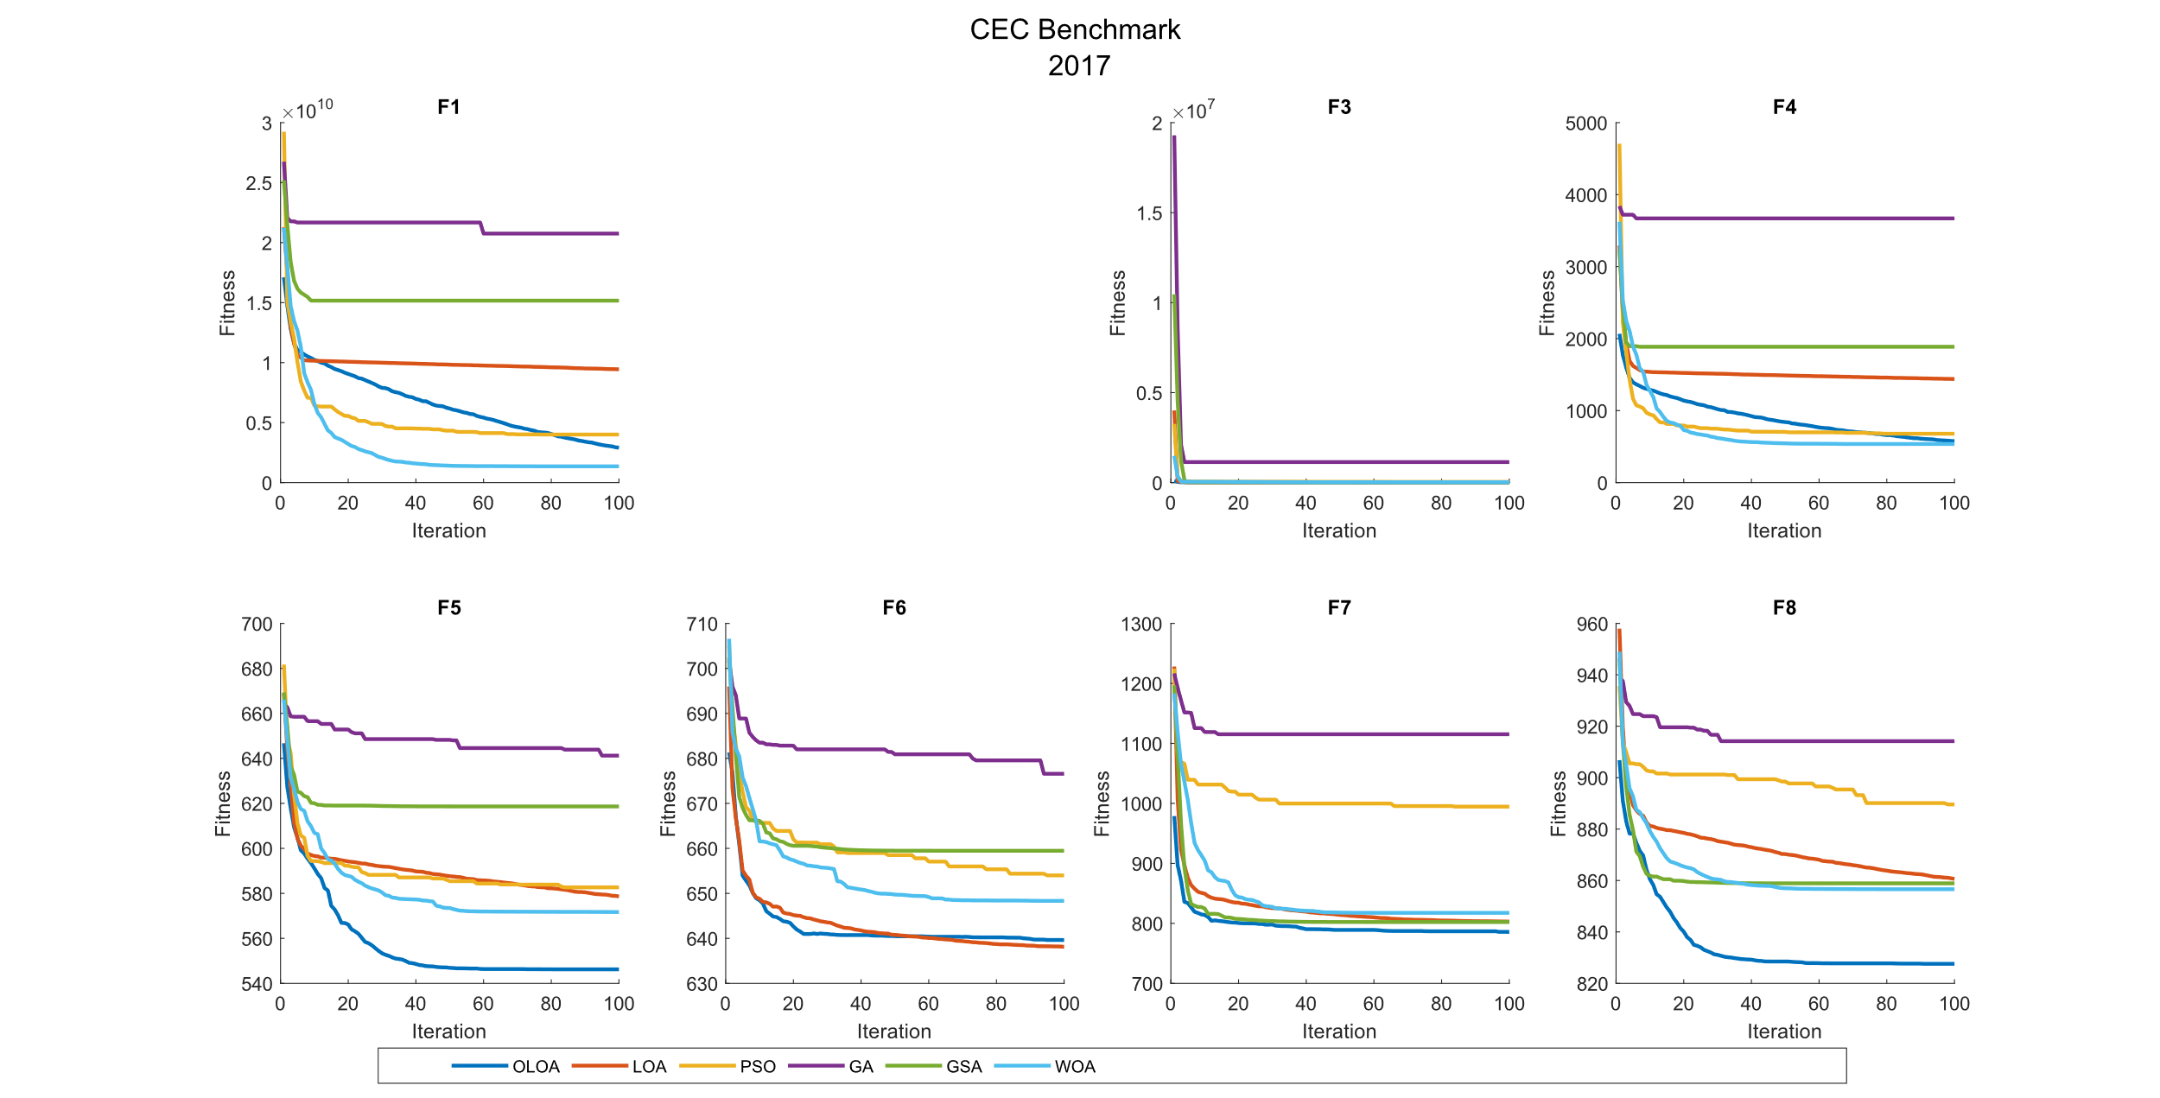 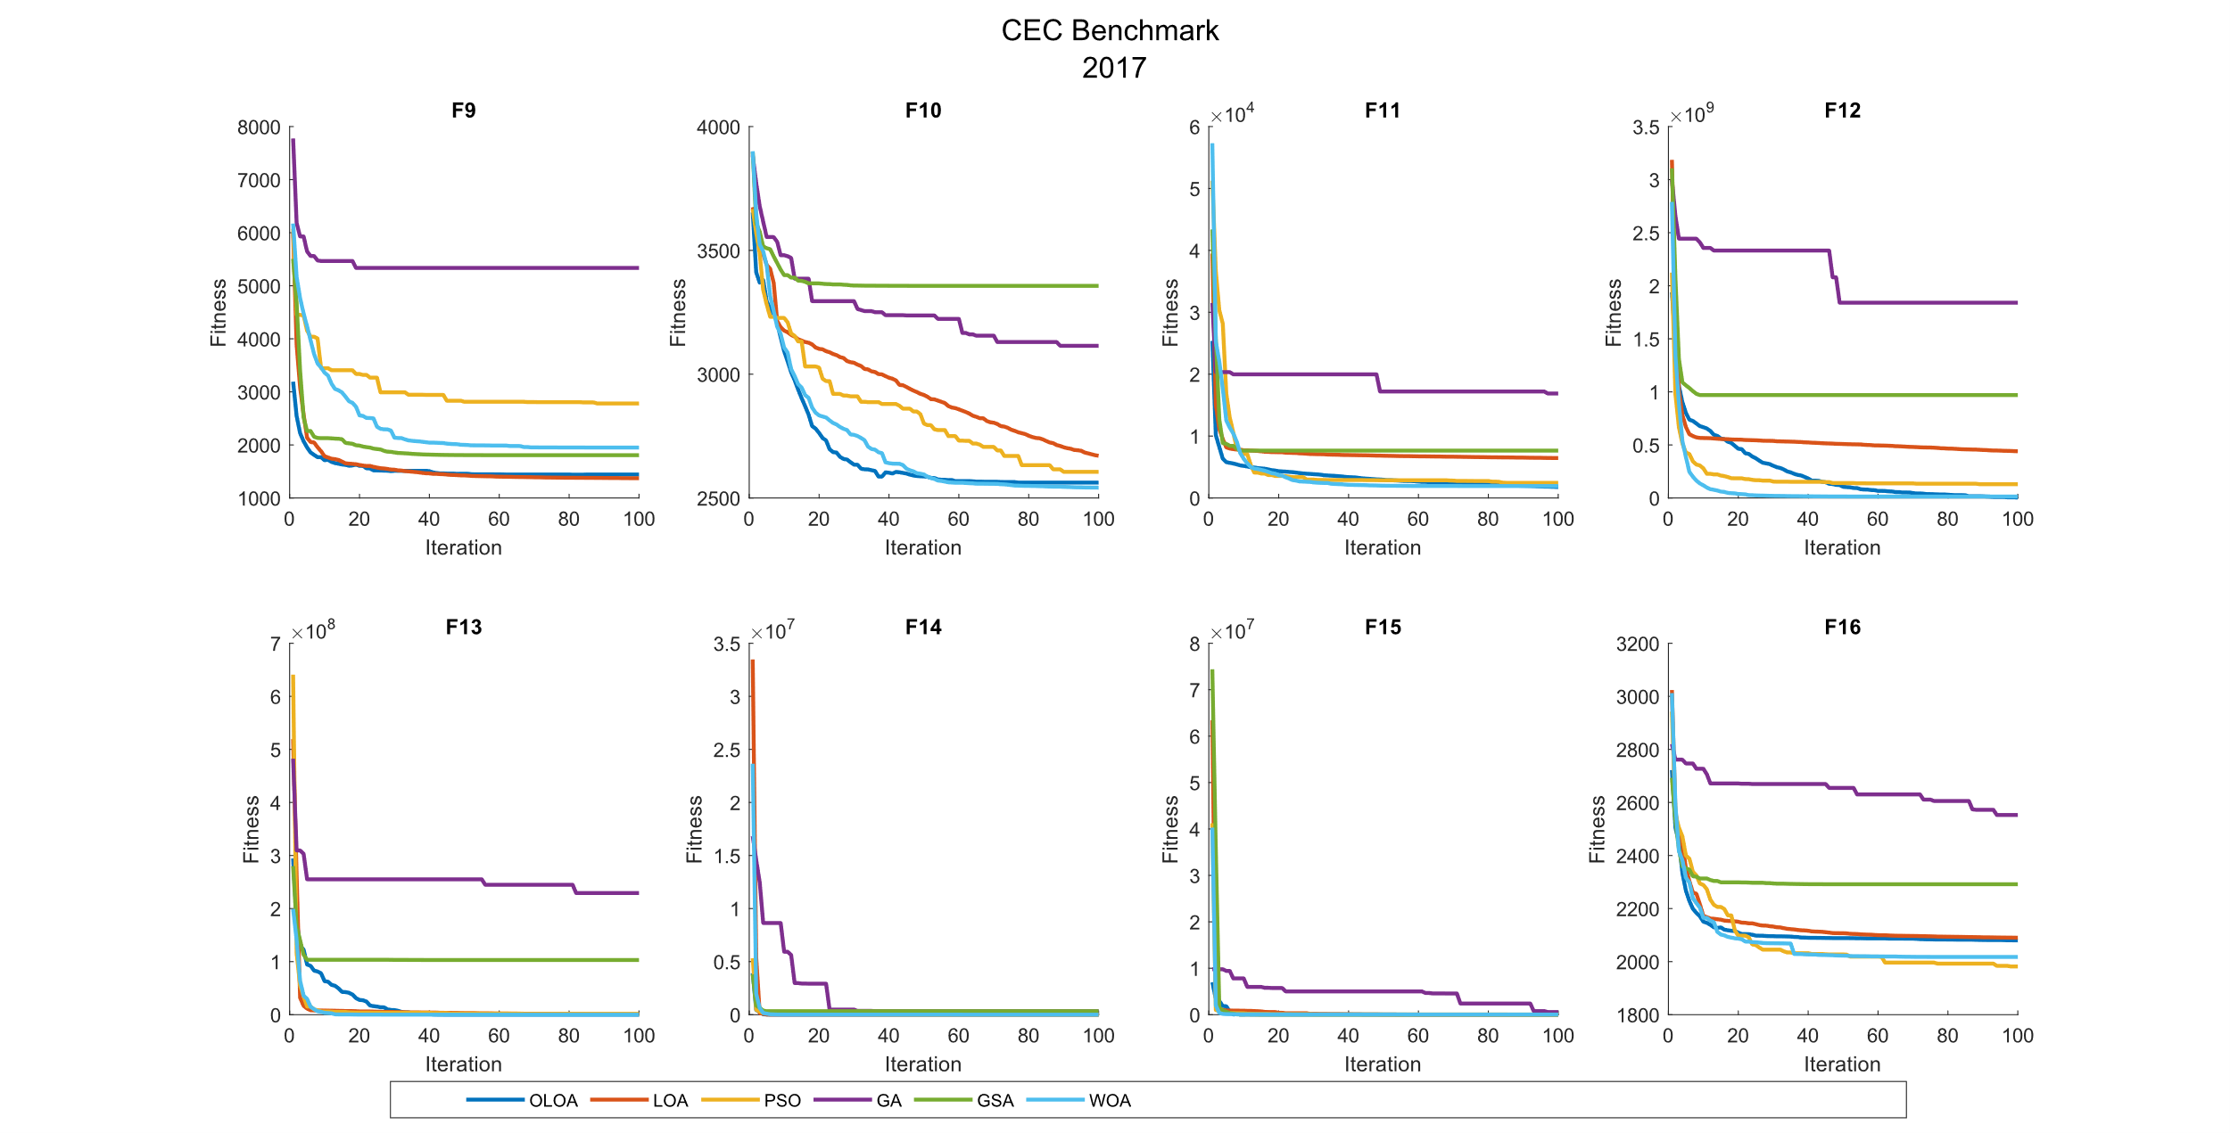 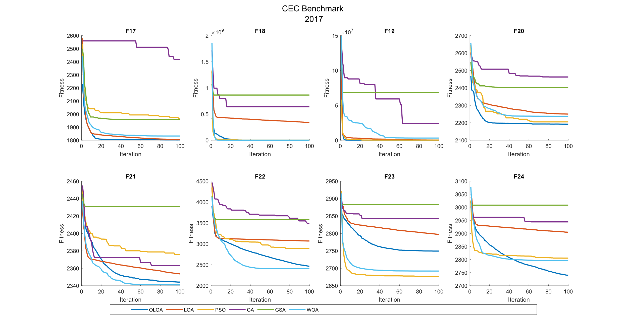 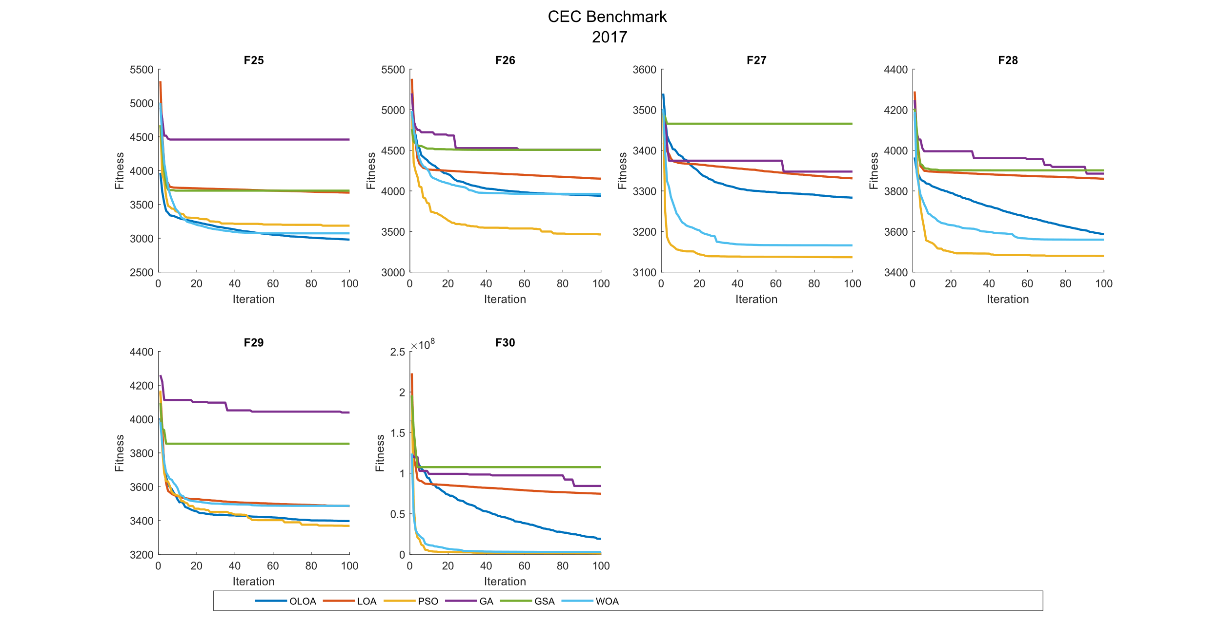

CEC 2017 Benchmark Function 30 Dimensions

| **Comparison of optimization results for the CEC benchmark functions 2017 (30 Dim)** | | | | | | | | |
| --- | --- | --- | --- | --- | --- | --- | --- | --- |
|  | Function |  | OLOA | LOA | PSO | GA | GSA | WOA |
|  | F1 | Mean | 3.57E+10 | 5.67E+10 | 7.84E+10 | 1.20E+11 | 5.91E+10 | **2.64E+10** |
|  | Std | 6.86E+09 | 1.13E+10 | 9.63E+09 | 1.72E+10 | 8.93E+09 | 6.98E+09 |
|  | CPU | 0.034 | 0.020 | 0.033 | 0.042 | 0.253 | 0.033 |
|  | F2 | Mean | The Function F2 was Delete in CEC 2017 | | | | | |
|  | Std |
|  | CPU |
|  | F3 | Mean | **8.55E+04** | 1.27E+05 | 3.59E+05 | 1.81E+08 | 1.15E+05 | 3.13E+05 |
|  | Std | 1.51E+04 | 3.56E+04 | 5.66E+04 | 2.98E+08 | 2.75E+04 | 6.41E+04 |
|  | CPU | 0.039 | 0.023 | 0.034 | 0.058 | 0.227 | 0.028 |
|  | F4 | Mean | 8.21E+03 | 1.72E+04 | 1.43E+04 | 4.42E+04 | 2.47E+04 | **6.10E+03** |
|  | Std | 2.51E+03 | 4.25E+03 | 7.39E+03 | 1.44E+04 | 4.41E+03 | 2.00E+03 |
|  | CPU | 0.064 | 0.023 | 0.027 | 0.047 | 0.208 | 0.047 |
|  | F5 | Mean | **7.80E+02** | 8.77E+02 | 1.00E+03 | 1.13E+03 | 9.68E+02 | 9.26E+02 |
|  | Std | 4.42E+01 | 3.35E+01 | 5.36E+01 | 6.69E+01 | 3.03E+01 | 5.12E+01 |
|  | CPU | 0.058 | 0.031 | 0.045 | 0.094 | 0.278 | 0.050 |
|  | F6 | Mean | **6.74E+02** | 6.75E+02 | 7.00E+02 | 7.21E+02 | 7.04E+02 | 6.94E+02 |
|  | Std | 4.97E+00 | 7.75E+00 | 1.29E+01 | 1.07E+01 | 5.34E+00 | 1.01E+01 |
|  | CPU | 0.142 | 0.077 | 0.063 | 0.108 | 0.319 | 0.077 |
|  | F7 | Mean | **1.38E+03** | 1.49E+03 | 3.00E+03 | 3.29E+03 | 1.49E+03 | 1.39E+03 |
|  | Std | 8.92E+01 | 1.83E+02 | 3.29E+02 | 2.86E+02 | 1.22E+02 | 7.79E+01 |
|  | CPU | 0.066 | 0.052 | 0.092 | 0.089 | 0.273 | 0.075 |
|  | F8 | Mean | **1.00E+03** | 1.12E+03 | 1.31E+03 | 1.36E+03 | 1.17E+03 | 1.16E+03 |
|  | Std | 3.88E+01 | 4.10E+01 | 3.71E+01 | 5.51E+01 | 2.44E+01 | 7.35E+01 |
|  | CPU | 0.095 | 0.044 | 0.052 | 0.095 | 0.322 | 0.097 |
|  | F9 | Mean | 1.02E+04 | **7.66E+03** | 2.64E+04 | 3.53E+04 | 1.31E+04 | 1.35E+04 |
|  | Std | 1.44E+03 | 1.49E+03 | 4.32E+03 | 4.15E+03 | 1.30E+03 | 2.73E+03 |
|  | CPU | 0.086 | 0.038 | 0.059 | 0.075 | 0.277 | 0.047 |
|  | F10 | Mean | **6.44E+03** | 8.77E+03 | 9.30E+03 | 9.42E+03 | 9.51E+03 | 8.89E+03 |
|  | Std | 5.58E+02 | 3.73E+02 | 3.62E+02 | 3.50E+02 | 5.34E+02 | 5.95E+02 |
|  | CPU | 0.088 | 0.047 | 0.056 | 0.078 | 0.259 | 0.061 |
|  | F11 | Mean | **6.01E+03** | 1.52E+04 | 2.69E+04 | 2.07E+05 | 1.21E+04 | 2.49E+04 |
|  | Std | 2.14E+03 | 5.32E+03 | 8.41E+03 | 3.06E+05 | 1.49E+03 | 8.79E+03 |
|  | CPU | 0.077 | 0.023 | 0.041 | 0.059 | 0.256 | 0.047 |
|  | F12 | Mean | 6.42E+09 | 1.43E+10 | 6.73E+09 | 2.56E+10 | 1.94E+10 | **3.13E+09** |
|  | Std | 3.43E+09 | 2.51E+09 | 2.34E+09 | 5.37E+09 | 2.70E+09 | 1.49E+09 |
|  | CPU | 0.081 | 0.036 | 0.047 | 0.073 | 0.264 | 0.058 |
|  | F13 | Mean | 2.72E+09 | 1.49E+10 | 3.88E+09 | 2.91E+10 | 2.25E+10 | **5.90E+08** |
|  | Std | 1.69E+09 | 8.49E+09 | 1.47E+09 | 8.60E+09 | 8.08E+09 | 5.26E+08 |
|  | CPU | 0.088 | 0.039 | 0.033 | 0.064 | 0.250 | 0.053 |
|  | F14 | Mean | **2.97E+06** | 1.27E+07 | 3.38E+06 | 6.17E+07 | 2.73E+07 | 6.41E+06 |
|  | Std | 3.65E+06 | 1.27E+07 | 3.39E+06 | 4.31E+07 | 3.42E+07 | 7.44E+06 |
|  | CPU | 0.097 | 0.047 | 0.042 | 0.077 | 0.286 | 0.056 |
|  | F15 | Mean | **2.90E+06** | 8.55E+08 | 7.37E+08 | 7.34E+09 | 1.33E+09 | 1.54E+08 |
|  | Std | 7.25E+06 | 9.46E+08 | 3.39E+08 | 3.40E+09 | 7.93E+08 | 2.22E+08 |
|  | CPU | 0.064 | 0.030 | 0.041 | 0.059 | 0.245 | 0.047 |
|  | F16 | Mean | 5.11E+03 | 6.30E+03 | 4.78E+03 | 1.12E+04 | 9.96E+03 | **4.76E+03** |
|  | Std | 1.02E+03 | 2.99E+03 | 3.83E+02 | 2.88E+03 | 3.22E+03 | 6.12E+02 |
|  | CPU | 0.072 | 0.036 | 0.036 | 0.066 | 0.273 | 0.053 |
|  | F17 | Mean | **2.87E+03** | 4.17E+03 | 3.55E+03 | 4.78E+04 | 1.90E+04 | 3.26E+03 |
|  | Std | 4.57E+02 | 1.20E+03 | 2.55E+02 | 3.84E+04 | 1.40E+04 | 3.37E+02 |
|  | CPU | 0.197 | 0.080 | 0.070 | 0.102 | 0.277 | 0.072 |
|  | F18 | Mean | **1.38E+07** | 2.12E+08 | 3.91E+07 | 9.57E+08 | 3.39E+08 | 1.93E+07 |
|  | Std | 1.21E+07 | 2.12E+08 | 2.19E+07 | 5.73E+08 | 4.35E+08 | 1.45E+07 |
|  | CPU | 0.073 | 0.036 | 0.039 | 0.064 | 0.253 | 0.055 |
|  | F19 | Mean | **2.19E+07** | 1.04E+09 | 1.19E+09 | 9.27E+09 | 2.01E+09 | 1.59E+08 |
|  | Std | 3.87E+07 | 8.67E+08 | 6.67E+08 | 4.08E+09 | 1.23E+09 | 1.14E+08 |
|  | CPU | 0.667 | 0.238 | 0.184 | 0.217 | 0.436 | 0.213 |
|  | F20 | Mean | **2.88E+03** | 3.13E+03 | 3.20E+03 | 3.29E+03 | 3.36E+03 | 3.11E+03 |
|  | Std | 2.53E+02 | 3.18E+02 | 1.64E+02 | 1.38E+02 | 2.81E+02 | 1.85E+02 |
|  | CPU | 0.241 | 0.075 | 0.063 | 0.083 | 0.292 | 0.069 |
|  | F21 | Mean | **2.55E+03** | 2.72E+03 | 2.76E+03 | 2.91E+03 | 2.83E+03 | 2.70E+03 |
|  | Std | 3.69E+01 | 5.20E+01 | 3.01E+01 | 6.14E+01 | 6.61E+01 | 6.88E+01 |
|  | CPU | 0.208 | 0.095 | 0.083 | 0.100 | 0.278 | 0.083 |
|  | F22 | Mean | **7.96E+03** | 9.75E+03 | 9.94E+03 | 1.09E+04 | 1.01E+04 | 9.17E+03 |
|  | Std | 8.33E+02 | 6.14E+02 | 1.12E+03 | 5.52E+02 | 6.92E+02 | 1.79E+03 |
|  | CPU | 0.253 | 0.075 | 0.080 | 0.103 | 0.272 | 0.091 |
|  | F23 | Mean | 3.67E+03 | 3.81E+03 | 3.25E+03 | 4.03E+03 | 4.06E+03 | **3.23E+03** |
|  | Std | 1.22E+02 | 1.92E+02 | 1.20E+02 | 3.66E+02 | 4.37E+02 | 1.28E+02 |
|  | CPU | 0.275 | 0.100 | 0.094 | 0.106 | 0.305 | 0.116 |
|  | F24 | Mean | 3.91E+03 | 4.56E+03 | **3.29E+03** | 4.27E+03 | 4.61E+03 | 3.37E+03 |
|  | Std | 1.60E+02 | 2.35E+02 | 9.68E+01 | 2.34E+02 | 2.49E+02 | 1.45E+02 |
|  | CPU | 0.291 | 0.094 | 0.088 | 0.130 | 0.311 | 0.113 |
|  | F25 | Mean | **3.81E+03** | 5.63E+03 | 1.35E+04 | 1.87E+04 | 6.24E+03 | 3.83E+03 |
|  | Std | 3.29E+02 | 8.69E+02 | 3.61E+03 | 4.42E+03 | 8.89E+02 | 1.99E+02 |
|  | CPU | 0.259 | 0.097 | 0.092 | 0.114 | 0.298 | 0.092 |
|  | F26 | Mean | 9.45E+03 | 1.16E+04 | 9.28E+03 | 1.74E+04 | 1.30E+04 | **9.14E+03** |
|  | Std | 8.62E+02 | 1.51E+03 | 9.04E+02 | 1.57E+03 | 7.99E+02 | 1.05E+03 |
|  | CPU | 0.334 | 0.105 | 0.113 | 0.130 | 0.291 | 0.144 |
|  | F27 | Mean | 4.49E+03 | 5.34E+03 | **3.45E+03** | 5.37E+03 | 5.81E+03 | 3.65E+03 |
|  | Std | 2.71E+02 | 3.56E+02 | 9.68E+01 | 6.83E+02 | 6.67E+02 | 1.63E+02 |
|  | CPU | 0.403 | 0.172 | 0.134 | 0.145 | 0.334 | 0.141 |
|  | F28 | Mean | 5.31E+03 | 8.00E+03 | 7.35E+03 | 1.34E+04 | 8.94E+03 | **5.20E+03** |
|  | Std | 7.27E+02 | 1.25E+03 | 1.17E+03 | 2.53E+03 | 6.92E+02 | 5.03E+02 |
|  | CPU | 0.339 | 0.123 | 0.100 | 0.125 | 0.317 | 0.138 |
|  | F29 | Mean | 6.60E+03 | 9.43E+03 | **5.77E+03** | 2.84E+04 | 1.24E+04 | 6.10E+03 |
|  | Std | 1.59E+03 | 4.22E+03 | 5.57E+02 | 2.86E+04 | 5.69E+03 | 7.48E+02 |
|  | CPU | 0.272 | 0.113 | 0.100 | 0.128 | 0.330 | 0.114 |
|  | F30 | Mean | **2.88E+08** | 2.59E+09 | 5.26E+08 | 4.03E+09 | 3.20E+09 | 2.96E+08 |
|  | Std | 2.72E+08 | 1.40E+09 | 3.84E+08 | 1.56E+09 | 1.68E+09 | 1.67E+08 |
|  | CPU | 0.752 | 0.259 | 0.256 | 0.284 | 0.414 | 0.208 |

|  |  |  |  |  |  |  |
| --- | --- | --- | --- | --- | --- | --- |
| **P-value of the T-test analysis for the CEC benchmark functions 2017 (30 Dim)** | | | | | | |
|  | Function | OLOA versus LOA | OLOA versus PSO | OLOA versus GA | OLOA versus GSA | OLOA versus WOA |
|  | F1 | 8.98E-05 | 1.14E-09 | 2.46E-11 | 3.72E-06 | 7.29E-03 |
|  | F2 | Deleted | | | | |
|  | F3 | 3.07E-03 | 1.65E-11 | 7.11E-02 | 7.27E-03 | 2.23E-09 |
|  | F4 | 1.83E-05 | 2.34E-02 | 3.60E-07 | 5.91E-09 | 5.22E-02 |
|  | F5 | 2.87E-05 | 8.06E-09 | 4.99E-11 | 1.82E-09 | 2.15E-06 |
|  | F6 | 7.67E-01 | 1.48E-05 | 2.36E-10 | 1.63E-10 | 3.55E-05 |
|  | F7 | 1.29E-01 | 1.24E-11 | 8.60E-14 | 4.59E-02 | 9.21E-01 |
|  | F8 | 4.96E-06 | 7.71E-13 | 2.74E-12 | 7.38E-10 | 1.03E-05 |
|  | F9 | 9.49E-04 | 1.44E-09 | 5.60E-13 | 2.21E-04 | 3.92E-03 |
|  | F10 | 2.09E-09 | 6.70E-11 | 2.76E-11 | 2.45E-10 | 1.91E-08 |
|  | F11 | 7.75E-05 | 4.98E-07 | 5.20E-02 | 7.06E-07 | 3.39E-06 |
|  | F12 | 1.56E-05 | 8.11E-01 | 1.82E-08 | 2.34E-08 | 1.22E-02 |
|  | F13 | 3.15E-04 | 1.20E-01 | 1.93E-08 | 5.36E-07 | 1.28E-03 |
|  | F14 | 3.11E-02 | 7.96E-01 | 4.41E-04 | 3.83E-02 | 2.06E-01 |
|  | F15 | 1.07E-02 | 2.09E-06 | 2.16E-06 | 4.76E-05 | 4.51E-02 |
|  | F16 | 2.50E-01 | 3.55E-01 | 6.01E-06 | 2.48E-04 | 3.66E-01 |
|  | F17 | 5.06E-03 | 6.49E-04 | 1.64E-03 | 1.86E-03 | 4.42E-02 |
|  | F18 | 8.67E-03 | 4.87E-03 | 5.95E-05 | 2.94E-02 | 3.63E-01 |
|  | F19 | 1.62E-03 | 3.10E-05 | 1.13E-06 | 7.08E-05 | 2.13E-03 |
|  | F20 | 6.05E-02 | 3.11E-03 | 2.38E-04 | 7.68E-04 | 3.20E-02 |
|  | F21 | 2.32E-07 | 5.47E-11 | 5.57E-12 | 7.16E-10 | 1.18E-05 |
|  | F22 | 3.36E-05 | 2.87E-04 | 2.86E-08 | 5.15E-06 | 6.85E-02 |
|  | F23 | 6.79E-02 | 2.95E-07 | 8.52E-03 | 1.42E-02 | 3.31E-07 |
|  | F24 | 9.97E-07 | 3.78E-09 | 8.11E-04 | 7.56E-07 | 2.52E-07 |
|  | F25 | 7.46E-06 | 1.14E-07 | 3.67E-09 | 1.98E-07 | 8.53E-01 |
|  | F26 | 1.14E-03 | 6.62E-01 | 3.68E-11 | 1.87E-08 | 4.70E-01 |
|  | F27 | 1.09E-05 | 1.10E-09 | 1.37E-03 | 1.70E-05 | 1.24E-07 |
|  | F28 | 1.48E-05 | 1.87E-04 | 1.40E-08 | 1.11E-09 | 6.90E-01 |
|  | F29 | 6.25E-02 | 1.40E-01 | 2.69E-02 | 6.20E-03 | 3.79E-01 |
|  | F30 | 7.36E-05 | 1.27E-01 | 6.26E-07 | 3.72E-05 | 9.32E-01 |

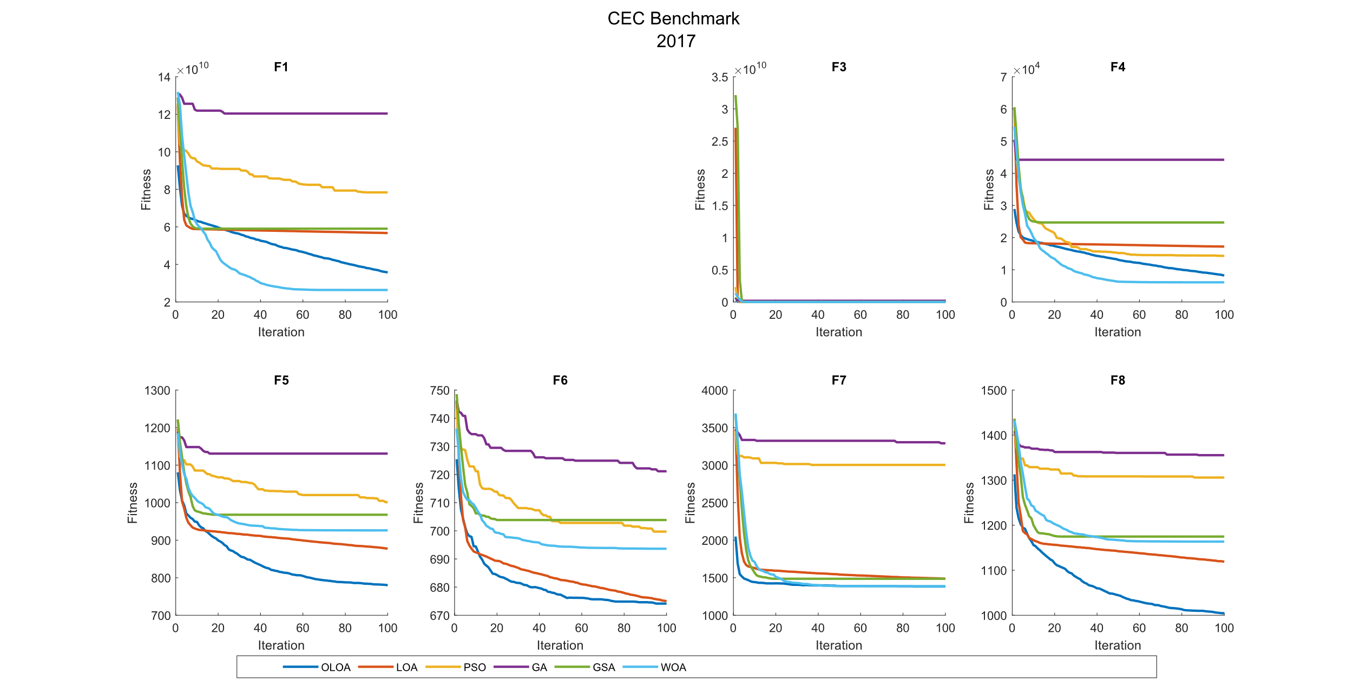 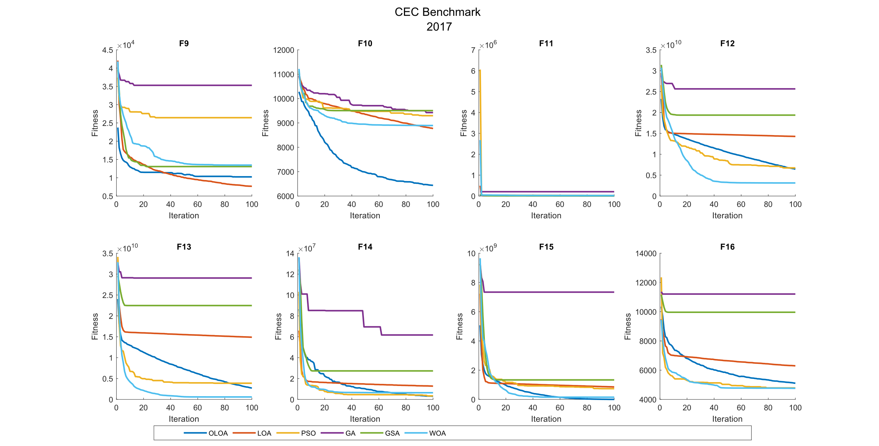 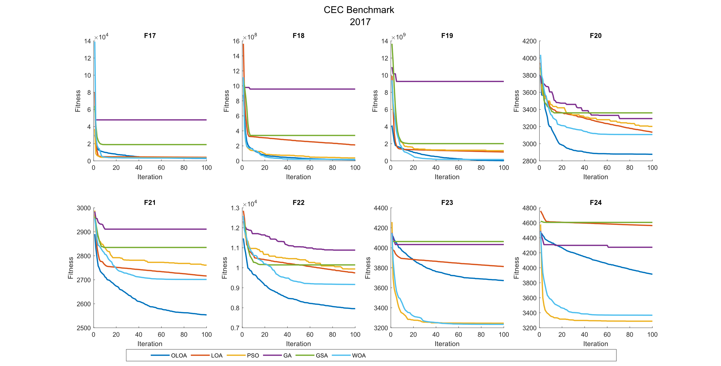 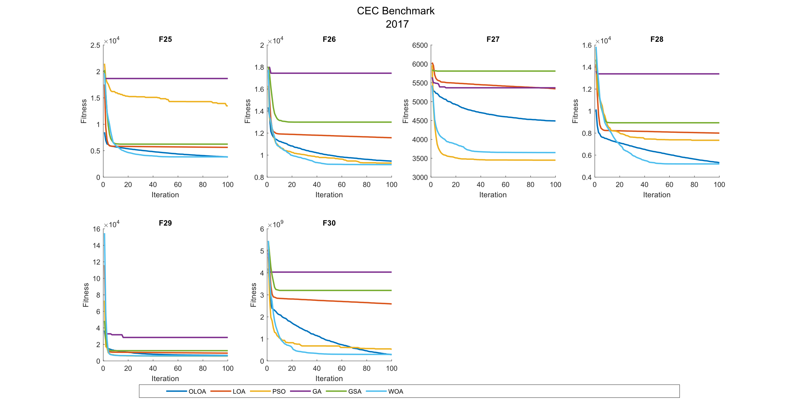

CEC 2017 Benchmark Function 50 Dimensions

| **Comparison of optimization results for the CEC benchmark functions 2017 (50 Dim)** | | | | | | | | |
| --- | --- | --- | --- | --- | --- | --- | --- | --- |
|  | Function |  | OLOA | LOA | PSO | GA | GSA | WOA |
|  | F1 | Mean | 8.09E+10 | 1.16E+11 | 2.15E+11 | 2.39E+11 | 1.20E+11 | **6.96E+10** |
|  | Std | 7.01E+09 | 2.36E+10 | 2.39E+10 | 1.51E+10 | 1.27E+10 | 7.30E+09 |
|  | CPU | 0.088 | 0.038 | 0.059 | 0.092 | 0.392 | 0.091 |
|  | F2 | Mean | The Function F2 was Delete in CEC 2017 | | | | | |
|  | Std |
|  | CPU |
|  | F3 | Mean | **2.03E+05** | 2.39E+05 | 6.14E+05 | 8.18E+11 | 2.52E+06 | 3.52E+05 |
|  | Std | 2.39E+04 | 4.08E+04 | 1.17E+05 | 2.11E+12 | 7.11E+06 | 6.26E+04 |
|  | CPU | 0.192 | 0.050 | 0.106 | 0.094 | 0.359 | 0.063 |
|  | F4 | Mean | 2.31E+04 | 4.57E+04 | 5.10E+04 | 1.07E+05 | 4.54E+04 | **1.80E+04** |
|  | Std | 4.02E+03 | 7.43E+03 | 2.16E+04 | 1.43E+04 | 6.93E+03 | 1.95E+03 |
|  | CPU | 0.122 | 0.061 | 0.055 | 0.116 | 0.447 | 0.095 |
|  | F5 | Mean | **9.79E+02** | 1.17E+03 | 1.59E+03 | 1.61E+03 | 1.26E+03 | 1.22E+03 |
|  | Std | 4.49E+01 | 4.14E+01 | 4.66E+01 | 6.00E+01 | 2.35E+01 | 4.36E+01 |
|  | CPU | 0.216 | 0.064 | 0.100 | 0.123 | 0.413 | 0.106 |
|  | F6 | Mean | **6.84E+02** | 6.89E+02 | 7.33E+02 | 7.39E+02 | 7.11E+02 | 7.08E+02 |
|  | Std | 4.89E+00 | 1.00E+01 | 1.28E+01 | 8.16E+00 | 7.40E+00 | 1.10E+01 |
|  | CPU | 0.320 | 0.122 | 0.152 | 0.133 | 0.456 | 0.116 |
|  | F7 | Mean | **1.98E+03** | 2.33E+03 | 5.90E+03 | 5.94E+03 | 2.38E+03 | 2.00E+03 |
|  | Std | 8.13E+01 | 2.26E+02 | 3.73E+02 | 3.91E+02 | 1.38E+02 | 8.04E+01 |
|  | CPU | 0.170 | 0.055 | 0.109 | 0.133 | 0.384 | 0.072 |
|  | F8 | Mean | **1.27E+03** | 1.49E+03 | 1.80E+03 | 1.92E+03 | 1.57E+03 | 1.47E+03 |
|  | Std | 4.23E+01 | 3.00E+01 | 9.19E+01 | 4.46E+01 | 4.39E+01 | 5.81E+01 |
|  | CPU | 0.170 | 0.069 | 0.061 | 0.088 | 0.409 | 0.072 |
|  | F9 | Mean | 3.82E+04 | **2.27E+04** | 8.54E+04 | 9.54E+04 | 4.57E+04 | 4.27E+04 |
|  | Std | 6.95E+03 | 2.67E+03 | 9.97E+03 | 1.00E+04 | 5.16E+03 | 1.01E+04 |
|  | CPU | 0.166 | 0.073 | 0.058 | 0.091 | 0.395 | 0.072 |
|  | F10 | Mean | **1.12E+04** | 1.52E+04 | 1.59E+04 | 1.59E+04 | 1.66E+04 | 1.54E+04 |
|  | Std | 6.53E+02 | 5.29E+02 | 7.49E+02 | 6.55E+02 | 3.24E+02 | 6.07E+02 |
|  | CPU | 0.163 | 0.070 | 0.088 | 0.109 | 0.428 | 0.084 |
|  | F11 | Mean | 2.13E+04 | 3.45E+04 | 8.08E+04 | 1.34E+05 | 3.39E+04 | **2.09E+04** |
|  | Std | 5.65E+03 | 8.17E+03 | 2.46E+04 | 1.19E+05 | 5.58E+03 | 4.55E+03 |
|  | CPU | 0.128 | 0.048 | 0.063 | 0.083 | 0.388 | 0.077 |
|  | F12 | Mean | 5.55E+10 | 8.71E+10 | 4.57E+10 | 1.34E+11 | 9.36E+10 | **2.21E+10** |
|  | Std | 1.40E+10 | 1.91E+10 | 6.04E+09 | 3.00E+10 | 1.33E+10 | 7.65E+09 |
|  | CPU | 0.153 | 0.064 | 0.072 | 0.081 | 0.414 | 0.092 |
|  | F13 | Mean | 1.79E+10 | 4.94E+10 | 1.90E+10 | 7.81E+10 | 6.95E+10 | **6.17E+09** |
|  | Std | 2.86E+09 | 1.06E+10 | 6.50E+09 | 1.89E+10 | 1.70E+10 | 2.45E+09 |
|  | CPU | 0.164 | 0.059 | 0.061 | 0.089 | 0.398 | 0.075 |
|  | F14 | Mean | 3.05E+07 | 2.01E+08 | 2.41E+07 | 3.78E+08 | 3.01E+08 | **1.05E+07** |
|  | Std | 1.74E+07 | 1.05E+08 | 1.56E+07 | 1.98E+08 | 5.84E+07 | 7.99E+06 |
|  | CPU | 0.209 | 0.072 | 0.067 | 0.105 | 0.395 | 0.091 |
|  | F15 | Mean | 1.58E+09 | 1.09E+10 | 5.63E+09 | 3.20E+10 | 1.29E+10 | **8.12E+08** |
|  | Std | 1.31E+09 | 3.64E+09 | 4.25E+09 | 6.46E+09 | 4.03E+09 | 4.53E+08 |
|  | CPU | 0.141 | 0.050 | 0.050 | 0.088 | 0.400 | 0.077 |
|  | F16 | Mean | **6.51E+03** | 9.66E+03 | 7.84E+03 | 1.63E+04 | 1.24E+04 | 7.77E+03 |
|  | Std | 1.11E+03 | 1.56E+03 | 5.09E+02 | 2.60E+03 | 2.14E+03 | 1.42E+03 |
|  | CPU | 0.163 | 0.064 | 0.069 | 0.102 | 0.391 | 0.080 |
|  | F17 | Mean | **4.25E+03** | 6.84E+03 | 1.87E+05 | 1.97E+06 | 2.35E+04 | 6.11E+03 |
|  | Std | 3.77E+02 | 1.67E+03 | 3.67E+05 | 1.87E+06 | 1.32E+04 | 1.60E+03 |
|  | CPU | 0.323 | 0.114 | 0.117 | 0.138 | 0.502 | 0.134 |
|  | F18 | Mean | **6.70E+07** | 2.23E+08 | 1.39E+08 | 1.09E+09 | 5.23E+08 | 1.26E+08 |
|  | Std | 3.87E+07 | 1.13E+08 | 7.69E+07 | 5.55E+08 | 3.14E+08 | 8.42E+07 |
|  | CPU | 0.116 | 0.056 | 0.073 | 0.088 | 0.397 | 0.064 |
|  | F19 | Mean | 1.63E+09 | 5.93E+09 | 3.64E+09 | 1.44E+10 | 7.39E+09 | **4.19E+08** |
|  | Std | 1.05E+09 | 2.14E+09 | 1.51E+09 | 4.87E+09 | 3.13E+09 | 2.81E+08 |
|  | CPU | 1.095 | 0.380 | 0.313 | 0.322 | 0.659 | 0.309 |
|  | F20 | Mean | **3.83E+03** | 4.12E+03 | 4.89E+03 | 4.80E+03 | 4.72E+03 | 4.27E+03 |
|  | Std | 2.94E+02 | 2.62E+02 | 2.28E+02 | 3.10E+02 | 1.96E+02 | 3.18E+02 |
|  | CPU | 0.433 | 0.133 | 0.111 | 0.155 | 0.442 | 0.123 |
|  | F21 | Mean | **2.91E+03** | 3.22E+03 | 3.32E+03 | 3.49E+03 | 3.46E+03 | 3.28E+03 |
|  | Std | 7.62E+01 | 1.39E+02 | 6.05E+01 | 1.04E+02 | 1.12E+02 | 1.93E+02 |
|  | CPU | 0.494 | 0.163 | 0.155 | 0.181 | 0.466 | 0.158 |
|  | F22 | Mean | **1.33E+04** | 1.68E+04 | 1.75E+04 | 1.82E+04 | 1.81E+04 | 1.68E+04 |
|  | Std | 1.80E+03 | 7.72E+02 | 4.87E+02 | 3.80E+02 | 3.39E+02 | 5.93E+02 |
|  | CPU | 0.530 | 0.186 | 0.169 | 0.184 | 0.503 | 0.203 |
|  | F23 | Mean | 4.60E+03 | 5.20E+03 | **3.98E+03** | 5.27E+03 | 5.32E+03 | 4.07E+03 |
|  | Std | 3.28E+02 | 3.76E+02 | 1.54E+02 | 3.47E+02 | 3.32E+02 | 1.88E+02 |
|  | CPU | 0.656 | 0.217 | 0.194 | 0.230 | 0.539 | 0.208 |
|  | F24 | Mean | 5.06E+03 | 5.78E+03 | **3.97E+03** | 5.68E+03 | 5.81E+03 | 4.22E+03 |
|  | Std | 2.65E+02 | 3.22E+02 | 1.74E+02 | 3.17E+02 | 3.91E+02 | 1.69E+02 |
|  | CPU | 0.672 | 0.213 | 0.158 | 0.220 | 0.508 | 0.202 |
|  | F25 | Mean | 1.07E+04 | 1.80E+04 | 5.48E+04 | 5.56E+04 | 1.86E+04 | **1.01E+04** |
|  | Std | 8.42E+02 | 4.22E+03 | 1.28E+04 | 8.18E+03 | 2.42E+03 | 1.54E+03 |
|  | CPU | 0.756 | 0.219 | 0.194 | 0.230 | 0.486 | 0.200 |
|  | F26 | Mean | **1.48E+04** | 1.91E+04 | 1.75E+04 | 3.21E+04 | 1.93E+04 | 1.64E+04 |
|  | Std | 7.32E+02 | 1.11E+03 | 2.05E+03 | 3.24E+03 | 1.08E+03 | 8.85E+02 |
|  | CPU | 0.808 | 0.267 | 0.228 | 0.267 | 0.588 | 0.253 |
|  | F27 | Mean | 7.02E+03 | 8.50E+03 | **4.35E+03** | 8.79E+03 | 8.43E+03 | 5.84E+03 |
|  | Std | 6.53E+02 | 8.64E+02 | 2.30E+02 | 6.13E+02 | 7.26E+02 | 7.46E+02 |
|  | CPU | 0.948 | 0.314 | 0.275 | 0.306 | 0.605 | 0.286 |
|  | F28 | Mean | 1.01E+04 | 1.33E+04 | 1.30E+04 | 2.40E+04 | 1.55E+04 | **9.32E+03** |
|  | Std | 9.71E+02 | 1.32E+03 | 1.66E+03 | 1.71E+03 | 8.96E+02 | 1.08E+03 |
|  | CPU | 0.839 | 0.330 | 0.250 | 0.272 | 0.572 | 0.253 |
|  | F29 | Mean | 1.82E+04 | 2.60E+05 | **1.46E+04** | 4.16E+06 | 1.60E+06 | 1.83E+04 |
|  | Std | 8.80E+03 | 3.43E+05 | 6.98E+03 | 4.01E+06 | 2.40E+06 | 8.08E+03 |
|  | CPU | 0.583 | 0.250 | 0.220 | 0.220 | 0.525 | 0.189 |
|  | F30 | Mean | 3.18E+09 | 9.56E+09 | 5.03E+09 | 1.91E+10 | 1.47E+10 | **1.02E+09** |
|  | Std | 2.25E+09 | 3.00E+09 | 1.71E+09 | 4.47E+09 | 6.57E+09 | 3.60E+08 |
|  | CPU | 1.314 | 0.467 | 0.403 | 0.409 | 0.722 | 0.406 |

|  |  |  |  |  |  |  |
| --- | --- | --- | --- | --- | --- | --- |
| **P-value of the T-test analysis for the CEC benchmark functions 2017 (50 Dim)** | | | | | | |
|  | Function | OLOA versus LOA | OLOA versus PSO | OLOA versus GA | OLOA versus GSA | OLOA versus WOA |
|  | F1 | 2.43E-04 | 1.62E-12 | 8.46E-17 | 9.64E-08 | 2.26E-03 |
|  | F2 | Deleted | | | | |
|  | F3 | 2.73E-02 | 2.57E-09 | 2.37E-01 | 3.17E-01 | 1.56E-06 |
|  | F4 | 1.10E-07 | 8.19E-04 | 7.25E-13 | 6.30E-08 | 1.85E-03 |
|  | F5 | 1.03E-08 | 8.13E-17 | 5.96E-16 | 7.18E-13 | 5.13E-10 |
|  | F6 | 1.31E-01 | 1.26E-09 | 4.26E-13 | 1.14E-08 | 4.66E-06 |
|  | F7 | 1.95E-04 | 2.02E-17 | 3.78E-17 | 3.41E-07 | 6.64E-01 |
|  | F8 | 7.59E-11 | 2.95E-12 | 1.41E-17 | 6.33E-12 | 7.50E-08 |
|  | F9 | 3.57E-06 | 3.42E-10 | 1.57E-11 | 1.33E-02 | 2.53E-01 |
|  | F10 | 1.32E-11 | 1.30E-11 | 4.66E-12 | 7.93E-15 | 1.92E-11 |
|  | F11 | 5.05E-04 | 6.36E-07 | 7.87E-03 | 8.40E-05 | 8.65E-01 |
|  | F12 | 5.15E-04 | 5.80E-02 | 5.79E-07 | 6.88E-06 | 3.34E-06 |
|  | F13 | 3.64E-08 | 6.36E-01 | 9.80E-09 | 2.14E-08 | 1.13E-08 |
|  | F14 | 7.87E-05 | 3.94E-01 | 2.95E-05 | 3.85E-11 | 3.81E-03 |
|  | F15 | 4.48E-07 | 9.98E-03 | 2.06E-11 | 1.13E-07 | 9.59E-02 |
|  | F16 | 6.15E-05 | 3.05E-03 | 2.11E-09 | 3.92E-07 | 4.15E-02 |
|  | F17 | 1.54E-04 | 1.34E-01 | 3.84E-03 | 2.18E-04 | 2.20E-03 |
|  | F18 | 6.52E-04 | 1.67E-02 | 1.64E-05 | 2.45E-04 | 5.83E-02 |
|  | F19 | 2.12E-05 | 2.77E-03 | 2.12E-07 | 3.04E-05 | 2.43E-03 |
|  | F20 | 2.87E-02 | 4.22E-08 | 1.01E-06 | 2.47E-07 | 4.20E-03 |
|  | F21 | 8.07E-06 | 9.59E-11 | 3.67E-11 | 1.99E-10 | 2.43E-05 |
|  | F22 | 1.98E-05 | 1.12E-06 | 1.11E-07 | 1.38E-07 | 1.79E-05 |
|  | F23 | 1.20E-03 | 4.14E-05 | 3.10E-04 | 1.12E-04 | 3.47E-04 |
|  | F24 | 3.32E-05 | 2.43E-09 | 1.70E-04 | 8.62E-05 | 1.14E-07 |
|  | F25 | 3.76E-05 | 2.47E-09 | 1.21E-12 | 1.30E-08 | 3.20E-01 |
|  | F26 | 7.88E-09 | 1.28E-03 | 2.65E-12 | 2.46E-09 | 5.41E-04 |
|  | F27 | 4.22E-04 | 4.03E-10 | 6.99E-06 | 2.42E-04 | 1.46E-03 |
|  | F28 | 1.15E-05 | 2.02E-04 | 1.41E-14 | 1.90E-10 | 9.10E-02 |
|  | F29 | 3.92E-02 | 3.31E-01 | 4.32E-03 | 5.21E-02 | 9.83E-01 |
|  | F30 | 4.10E-05 | 5.29E-02 | 8.47E-09 | 5.60E-05 | 7.50E-03 |

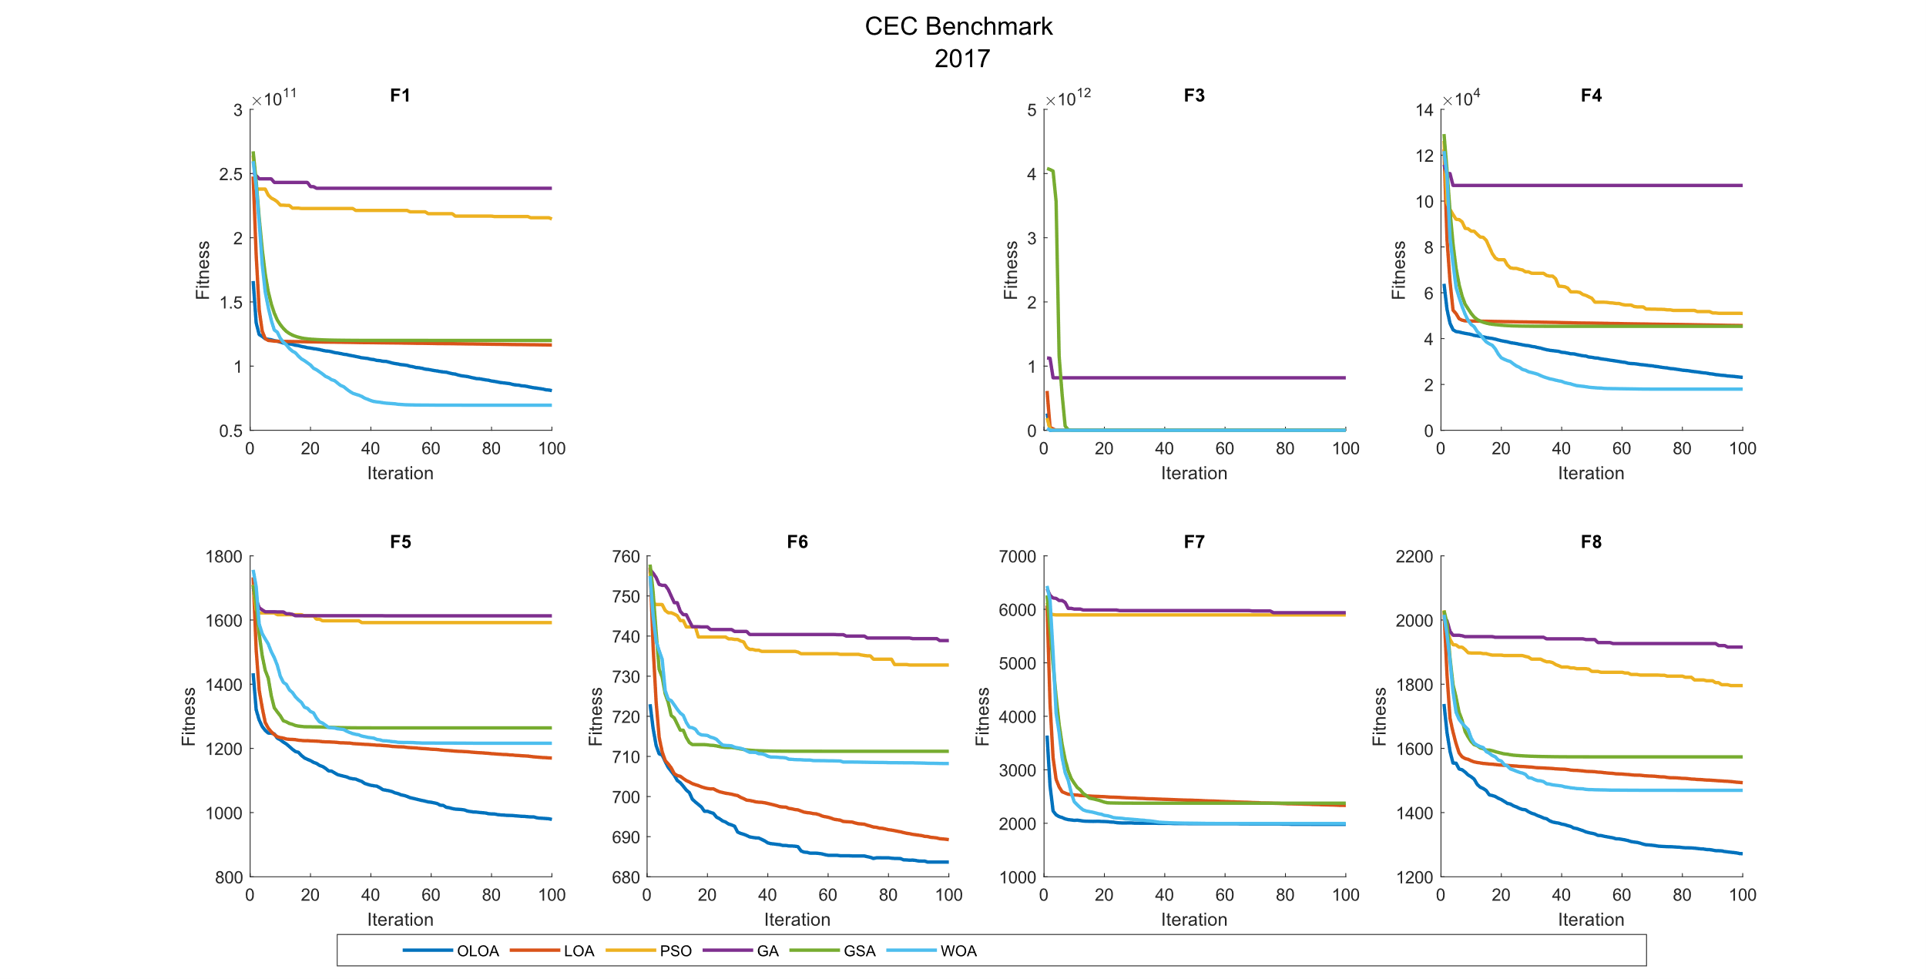 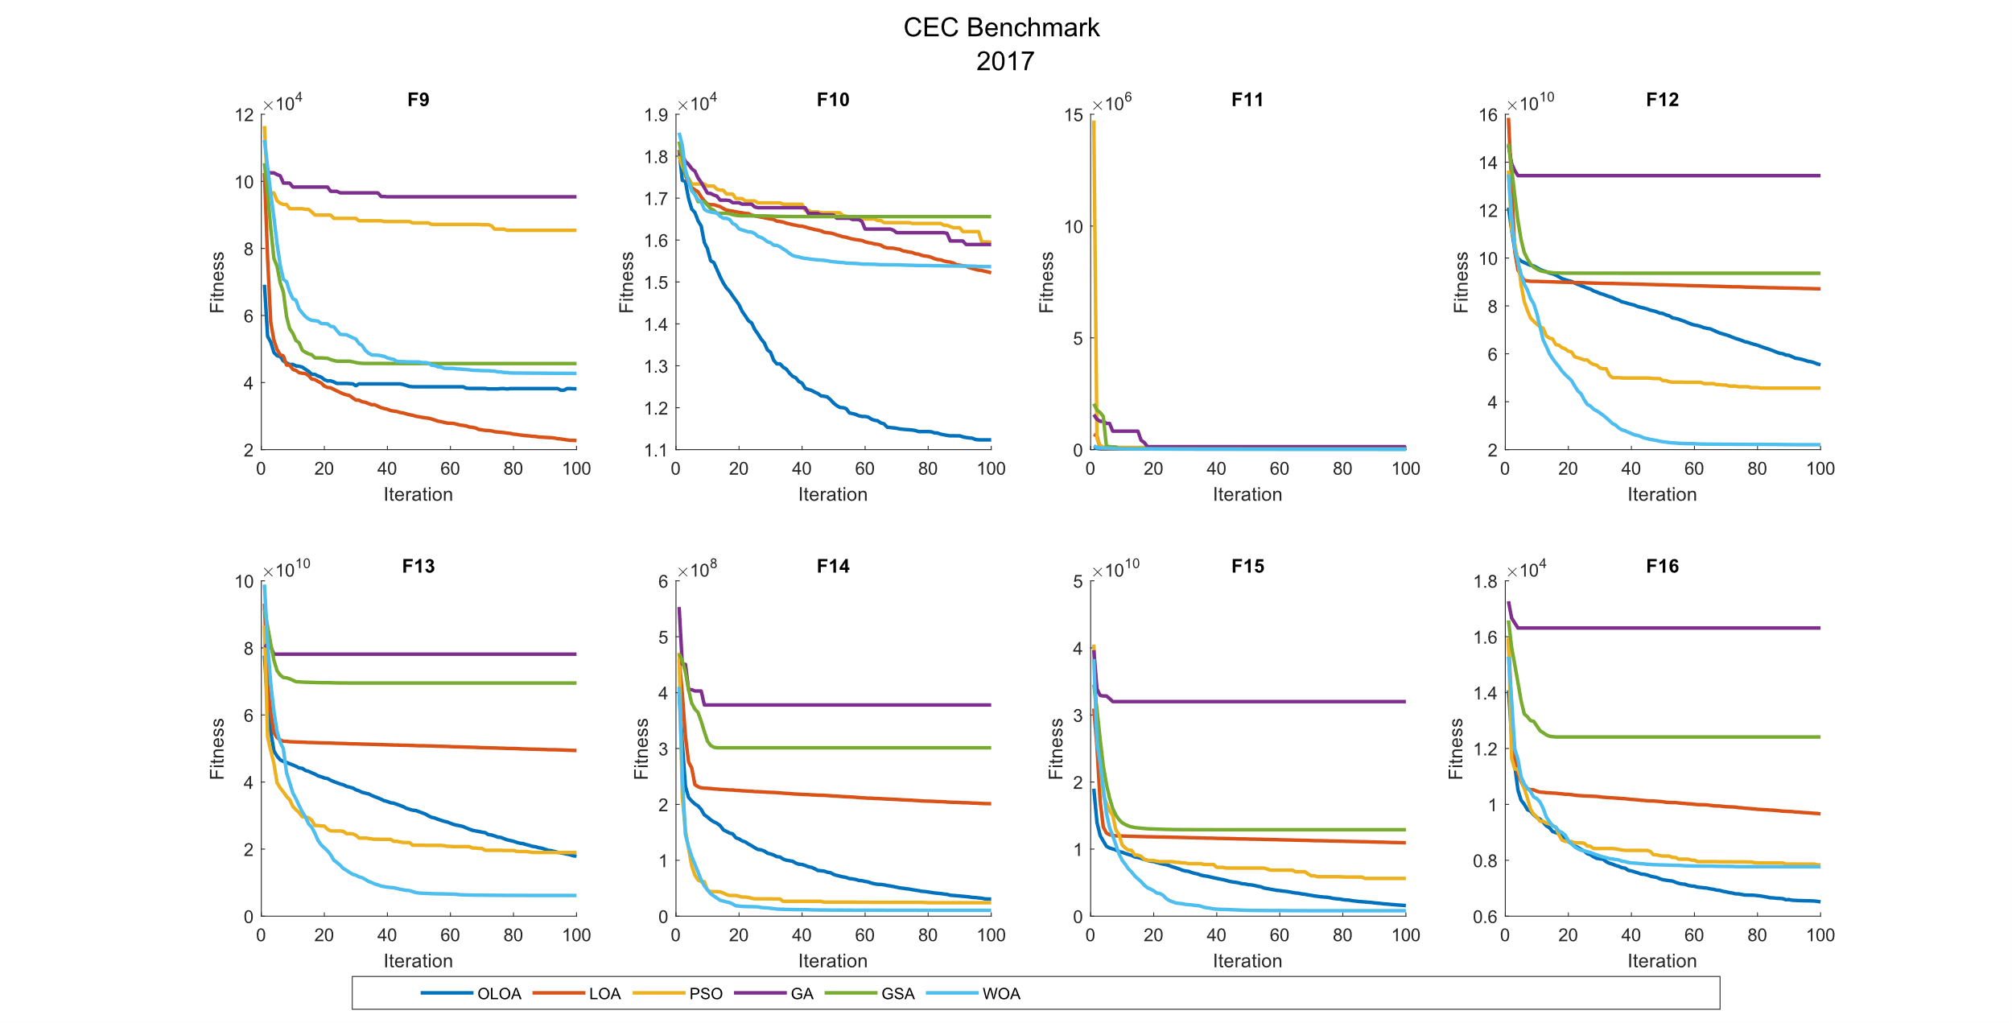 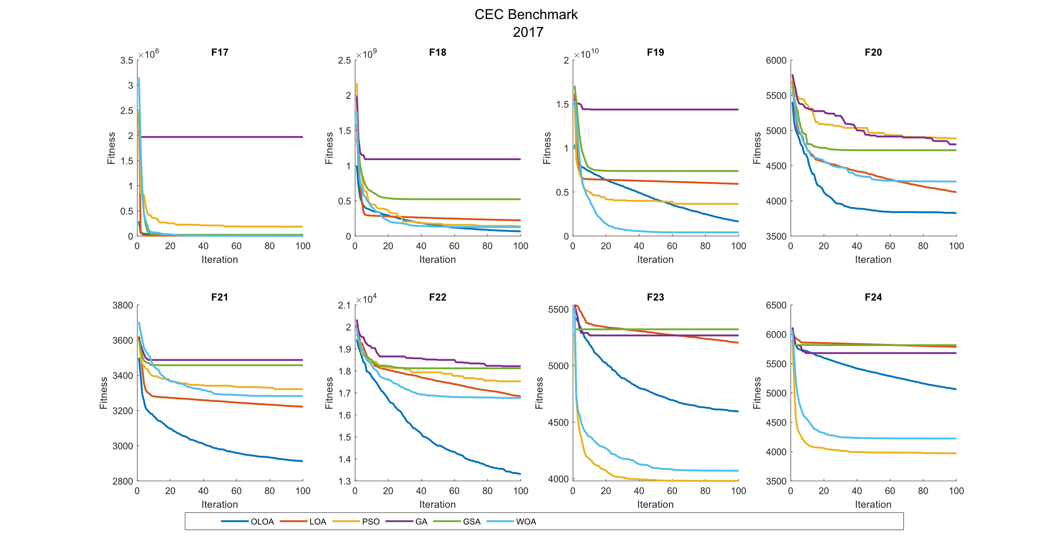 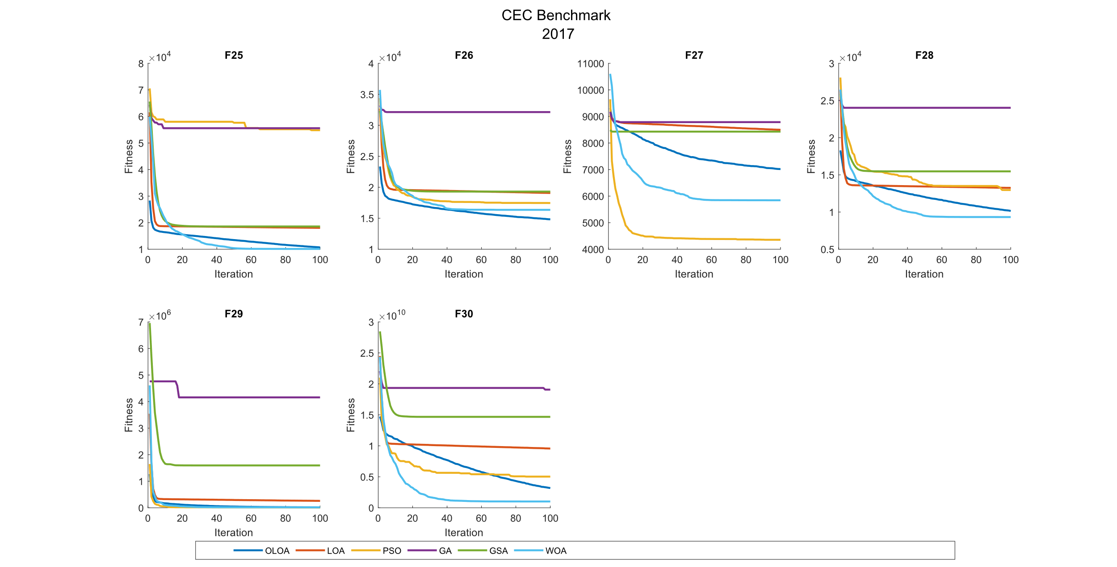

CEC 2017 Benchmark Function 100 Dimensions

| **Comparison of optimization results for the CEC benchmark functions 2017 (100 Dim)** | | | | | | | | |
| --- | --- | --- | --- | --- | --- | --- | --- | --- |
|  | Function |  | OLOA | LOA | PSO | GA | GSA | WOA |
|  | F1 | Mean | 2.14E+11 | 2.96E+11 | 5.81E+11 | 5.90E+11 | 3.28E+11 | **2.12E+11** |
|  | Std | 7.44E+09 | 2.73E+10 | 3.64E+10 | 3.02E+10 | 2.21E+10 | 1.23E+10 |
|  | CPU | 0.522 | 0.172 | 0.192 | 0.213 | 0.795 | 0.164 |
|  | F2 | Mean | The Function F2 was Delete in CEC 2017 | | | | | |
|  | Std |
|  | CPU |
|  | F3 | Mean | **4.60E+05** | 4.93E+05 | 1.55E+06 | 3.43E+13 | 4.36E+08 | 9.20E+05 |
|  | Std | 8.43E+04 | 7.16E+04 | 2.70E+05 | 9.52E+13 | 7.62E+08 | 8.71E+04 |
|  | CPU | 0.472 | 0.172 | 0.138 | 0.173 | 0.805 | 0.158 |
|  | F4 | Mean | 6.82E+04 | 1.20E+05 | 2.39E+05 | 3.09E+05 | 1.43E+05 | **6.14E+04** |
|  | Std | 9.36E+03 | 3.51E+04 | 2.69E+04 | 5.18E+04 | 3.22E+04 | 1.21E+04 |
|  | CPU | 0.534 | 0.194 | 0.175 | 0.191 | 0.795 | 0.192 |
|  | F5 | Mean | **1.74E+03** | 2.14E+03 | 3.02E+03 | 3.00E+03 | 2.35E+03 | 2.13E+03 |
|  | Std | 5.64E+01 | 1.10E+02 | 1.29E+02 | 6.00E+01 | 8.67E+01 | 9.33E+01 |
|  | CPU | 0.792 | 0.228 | 0.175 | 0.192 | 0.806 | 0.191 |
|  | F6 | Mean | **6.97E+02** | 7.03E+02 | 7.61E+02 | 7.50E+02 | 7.26E+02 | 7.17E+02 |
|  | Std | 3.90E+00 | 5.28E+00 | 6.95E+00 | 7.23E+00 | 2.89E+00 | 3.93E+00 |
|  | CPU | 0.983 | 0.411 | 0.248 | 0.300 | 0.939 | 0.283 |
|  | F7 | Mean | **3.91E+03** | 4.89E+03 | 1.31E+04 | 1.27E+04 | 5.98E+03 | 3.92E+03 |
|  | Std | 1.28E+02 | 5.11E+02 | 8.36E+02 | 3.72E+02 | 2.31E+02 | 1.05E+02 |
|  | CPU | 0.794 | 0.238 | 0.236 | 0.234 | 0.806 | 0.177 |
|  | F8 | Mean | **2.23E+03** | 2.57E+03 | 3.36E+03 | 3.40E+03 | 2.87E+03 | 2.59E+03 |
|  | Std | 4.76E+01 | 9.02E+01 | 1.53E+02 | 1.35E+02 | 8.76E+01 | 1.07E+02 |
|  | CPU | 0.642 | 0.214 | 0.172 | 0.230 | 0.794 | 0.205 |
|  | F9 | Mean | 8.51E+04 | **6.20E+04** | 2.12E+05 | 2.08E+05 | 1.16E+05 | 9.92E+04 |
|  | Std | 5.11E+03 | 6.52E+03 | 2.87E+04 | 1.43E+04 | 1.20E+04 | 2.83E+04 |
|  | CPU | 0.584 | 0.233 | 0.200 | 0.194 | 0.811 | 0.183 |
|  | F10 | Mean | **2.52E+04** | 3.16E+04 | 3.43E+04 | 3.41E+04 | 3.48E+04 | 3.15E+04 |
|  | Std | 1.52E+03 | 1.36E+03 | 5.72E+02 | 5.80E+02 | 5.55E+02 | 1.28E+03 |
|  | CPU | 0.622 | 0.205 | 0.194 | 0.216 | 0.852 | 0.227 |
|  | F11 | Mean | **2.26E+05** | 2.80E+05 | 7.81E+05 | 3.16E+10 | 2.32E+06 | 4.55E+05 |
|  | Std | 5.48E+04 | 4.39E+04 | 1.66E+05 | 8.25E+10 | 6.07E+06 | 1.09E+05 |
|  | CPU | 0.555 | 0.180 | 0.170 | 0.223 | 0.773 | 0.175 |
|  | F12 | Mean | 1.51E+11 | 2.04E+11 | 1.95E+11 | 3.58E+11 | 2.30E+11 | **1.15E+11** |
|  | Std | 1.22E+10 | 3.22E+10 | 1.71E+10 | 4.78E+10 | 1.95E+10 | 1.55E+10 |
|  | CPU | 0.650 | 0.227 | 0.191 | 0.225 | 0.834 | 0.175 |
|  | F13 | Mean | 2.91E+10 | 4.99E+10 | 4.26E+10 | 9.65E+10 | 5.93E+10 | **2.20E+10** |
|  | Std | 9.19E+09 | 1.01E+10 | 8.05E+09 | 8.49E+09 | 1.08E+10 | 5.14E+09 |
|  | CPU | 0.538 | 0.186 | 0.173 | 0.214 | 0.747 | 0.175 |
|  | F14 | Mean | **2.49E+07** | 2.32E+08 | 1.77E+08 | 1.03E+09 | 3.51E+08 | 5.80E+07 |
|  | Std | 1.06E+07 | 1.14E+08 | 1.02E+08 | 2.89E+08 | 1.89E+08 | 3.44E+07 |
|  | CPU | 0.639 | 0.214 | 0.197 | 0.245 | 0.884 | 0.227 |
|  | F15 | Mean | 1.36E+10 | 2.58E+10 | 1.83E+10 | 4.81E+10 | 3.15E+10 | **7.14E+09** |
|  | Std | 3.47E+09 | 3.48E+09 | 6.14E+09 | 4.58E+09 | 5.84E+09 | 2.04E+09 |
|  | CPU | 0.528 | 0.186 | 0.170 | 0.206 | 0.800 | 0.194 |
|  | F16 | Mean | **1.61E+04** | 2.33E+04 | 1.82E+04 | 4.08E+04 | 2.87E+04 | 2.02E+04 |
|  | Std | 2.96E+03 | 2.40E+03 | 2.07E+03 | 6.98E+03 | 3.41E+03 | 2.06E+03 |
|  | CPU | 0.570 | 0.203 | 0.191 | 0.219 | 0.855 | 0.178 |
|  | F17 | Mean | **1.06E+06** | 7.25E+06 | 2.10E+06 | 2.09E+08 | 3.13E+07 | 1.08E+06 |
|  | Std | 1.28E+06 | 7.84E+06 | 1.74E+06 | 1.18E+08 | 1.87E+07 | 1.12E+06 |
|  | CPU | 0.922 | 0.375 | 0.303 | 0.330 | 0.889 | 0.302 |
|  | F18 | Mean | **4.27E+07** | 2.88E+08 | 2.56E+08 | 1.75E+09 | 8.10E+08 | 5.38E+07 |
|  | Std | 2.32E+07 | 2.35E+08 | 7.71E+07 | 5.51E+08 | 2.82E+08 | 2.55E+07 |
|  | CPU | 0.569 | 0.195 | 0.169 | 0.192 | 0.842 | 0.198 |
|  | F19 | Mean | 1.39E+10 | 2.22E+10 | 1.64E+10 | 4.61E+10 | 3.49E+10 | **6.26E+09** |
|  | Std | 4.53E+09 | 3.42E+09 | 3.80E+09 | 8.87E+09 | 5.12E+09 | 2.49E+09 |
|  | CPU | 2.466 | 0.822 | 0.680 | 0.717 | 1.333 | 0.675 |
|  | F20 | Mean | **6.22E+03** | 7.57E+03 | 8.77E+03 | 8.71E+03 | 8.84E+03 | 7.89E+03 |
|  | Std | 6.94E+02 | 5.49E+02 | 4.15E+02 | 2.08E+02 | 5.18E+02 | 5.12E+02 |
|  | CPU | 1.297 | 0.313 | 0.263 | 0.284 | 0.839 | 0.303 |
|  | F21 | Mean | 4.82E+03 | 5.19E+03 | 4.96E+03 | 5.40E+03 | 5.41E+03 | **4.75E+03** |
|  | Std | 2.66E+02 | 3.27E+02 | 1.62E+02 | 2.65E+02 | 1.74E+02 | 2.30E+02 |
|  | CPU | 1.717 | 0.553 | 0.458 | 0.497 | 1.070 | 0.361 |
|  | F22 | Mean | **2.80E+04** | 3.53E+04 | 3.60E+04 | 3.65E+04 | 3.80E+04 | 3.51E+04 |
|  | Std | 8.42E+02 | 7.03E+02 | 7.24E+02 | 5.15E+02 | 5.54E+02 | 1.12E+03 |
|  | CPU | 1.777 | 0.588 | 0.430 | 0.536 | 1.038 | 0.483 |
|  | F23 | Mean | 7.18E+03 | 8.30E+03 | **5.48E+03** | 8.46E+03 | 8.33E+03 | 5.59E+03 |
|  | Std | 5.15E+02 | 5.39E+02 | 2.30E+02 | 8.24E+02 | 8.24E+02 | 2.87E+02 |
|  | CPU | 2.263 | 0.714 | 0.588 | 0.580 | 1.214 | 0.605 |
|  | F24 | Mean | 1.20E+04 | 1.43E+04 | **7.27E+03** | 1.36E+04 | 1.47E+04 | 7.65E+03 |
|  | Std | 6.07E+02 | 8.82E+02 | 5.02E+02 | 1.27E+03 | 1.37E+03 | 8.44E+02 |
|  | CPU | 2.291 | 0.717 | 0.594 | 0.659 | 1.219 | 0.613 |
|  | F25 | Mean | 2.07E+04 | 3.70E+04 | 1.30E+05 | 1.32E+05 | 4.14E+04 | **2.07E+04** |
|  | Std | 1.34E+03 | 6.88E+03 | 1.73E+04 | 1.70E+04 | 4.91E+03 | 2.49E+03 |
|  | CPU | 2.491 | 0.811 | 0.700 | 0.709 | 1.241 | 0.672 |
|  | F26 | Mean | 4.60E+04 | 6.31E+04 | 4.72E+04 | 9.73E+04 | 6.83E+04 | **4.40E+04** |
|  | Std | 3.02E+03 | 7.80E+03 | 3.83E+03 | 9.68E+03 | 5.68E+03 | 2.45E+03 |
|  | CPU | 2.770 | 0.925 | 0.742 | 0.789 | 1.380 | 0.698 |
|  | F27 | Mean | 1.24E+04 | 1.69E+04 | **6.84E+03** | 1.65E+04 | 1.82E+04 | 8.73E+03 |
|  | Std | 1.19E+03 | 1.31E+03 | 9.68E+02 | 1.46E+03 | 1.32E+03 | 1.02E+03 |
|  | CPU | 3.244 | 1.091 | 0.869 | 0.913 | 1.488 | 0.891 |
|  | F28 | Mean | 2.86E+04 | 3.86E+04 | 3.66E+04 | 6.96E+04 | 4.48E+04 | **2.45E+04** |
|  | Std | 2.10E+03 | 3.28E+03 | 3.25E+03 | 3.47E+03 | 5.29E+03 | 1.19E+03 |
|  | CPU | 3.044 | 0.988 | 0.819 | 0.816 | 1.450 | 0.806 |
|  | F29 | Mean | 1.24E+05 | 1.24E+06 | 1.58E+06 | 2.52E+07 | 3.20E+06 | **6.80E+04** |
|  | Std | 1.08E+05 | 1.17E+06 | 1.90E+06 | 2.00E+07 | 2.38E+06 | 6.21E+04 |
|  | CPU | 2.002 | 0.644 | 0.531 | 0.570 | 1.136 | 0.530 |
|  | F30 | Mean | 2.73E+10 | 4.03E+10 | 2.44E+10 | 7.80E+10 | 5.19E+10 | **1.42E+10** |
|  | Std | 7.07E+09 | 5.56E+09 | 2.86E+09 | 1.44E+10 | 5.43E+09 | 4.49E+09 |
|  | CPU | 3.430 | 1.133 | 0.914 | 0.959 | 1.542 | 0.947 |

|  |  |  |  |  |  |  |
| --- | --- | --- | --- | --- | --- | --- |
| **P-value of the T-test analysis for the CEC benchmark functions 2017 (100 Dim)** | | | | | | |
|  | Function | OLOA versus LOA | OLOA versus PSO | OLOA versus GA | OLOA versus GSA | OLOA versus WOA |
|  | F1 | 3.07E-08 | 3.88E-17 | 1.05E-18 | 7.67E-12 | 7.44E-01 |
|  | F2 | Deleted | | | | |
|  | F3 | 3.56E-01 | 3.88E-10 | 2.70E-01 | 8.75E-02 | 5.06E-10 |
|  | F4 | 2.47E-04 | 2.49E-13 | 2.43E-11 | 1.38E-06 | 1.81E-01 |
|  | F5 | 6.67E-09 | 1.68E-16 | 1.74E-20 | 3.29E-13 | 1.22E-09 |
|  | F6 | 7.56E-03 | 1.74E-15 | 6.66E-14 | 2.33E-13 | 1.05E-09 |
|  | F7 | 1.39E-05 | 7.42E-18 | 1.73E-23 | 2.37E-15 | 9.26E-01 |
|  | F8 | 3.66E-09 | 1.48E-14 | 1.10E-15 | 7.77E-14 | 1.31E-08 |
|  | F9 | 5.61E-08 | 5.44E-11 | 1.45E-15 | 6.06E-07 | 1.38E-01 |
|  | F10 | 1.09E-08 | 7.60E-13 | 1.09E-12 | 3.02E-13 | 8.26E-09 |
|  | F11 | 2.47E-02 | 8.03E-09 | 2.41E-01 | 2.90E-01 | 1.24E-05 |
|  | F12 | 1.38E-04 | 3.10E-06 | 9.91E-11 | 2.62E-09 | 2.00E-05 |
|  | F13 | 1.37E-04 | 2.63E-03 | 1.51E-12 | 2.69E-06 | 4.84E-02 |
|  | F14 | 1.94E-05 | 1.84E-04 | 2.18E-09 | 3.70E-05 | 9.49E-03 |
|  | F15 | 2.84E-07 | 4.77E-02 | 2.28E-13 | 1.34E-07 | 8.54E-05 |
|  | F16 | 1.34E-05 | 8.18E-02 | 5.53E-09 | 5.96E-08 | 2.02E-03 |
|  | F17 | 2.39E-02 | 1.43E-01 | 2.56E-05 | 7.39E-05 | 9.60E-01 |
|  | F18 | 4.15E-03 | 1.26E-07 | 1.20E-08 | 8.85E-08 | 3.19E-01 |
|  | F19 | 2.00E-04 | 1.90E-01 | 6.21E-09 | 1.37E-08 | 1.91E-04 |
|  | F20 | 1.38E-04 | 9.43E-09 | 2.45E-09 | 1.73E-08 | 9.05E-06 |
|  | F21 | 1.23E-02 | 1.64E-01 | 1.18E-04 | 1.30E-05 | 5.44E-01 |
|  | F22 | 3.76E-14 | 1.11E-14 | 4.82E-16 | 3.66E-17 | 4.09E-12 |
|  | F23 | 1.63E-04 | 1.93E-08 | 5.96E-04 | 1.49E-03 | 9.46E-08 |
|  | F24 | 3.15E-06 | 2.07E-13 | 1.87E-03 | 1.97E-05 | 9.15E-11 |
|  | F25 | 7.92E-07 | 9.79E-14 | 6.20E-14 | 1.62E-10 | 9.57E-01 |
|  | F26 | 4.52E-06 | 4.68E-01 | 4.38E-12 | 2.18E-09 | 1.22E-01 |
|  | F27 | 2.01E-07 | 1.14E-09 | 1.87E-06 | 4.49E-09 | 8.13E-07 |
|  | F28 | 1.88E-07 | 3.97E-06 | 2.55E-17 | 4.44E-08 | 3.73E-05 |
|  | F29 | 7.47E-03 | 2.57E-02 | 8.89E-04 | 6.92E-04 | 1.73E-01 |
|  | F30 | 2.37E-04 | 2.49E-01 | 8.73E-09 | 7.20E-08 | 1.02E-04 |

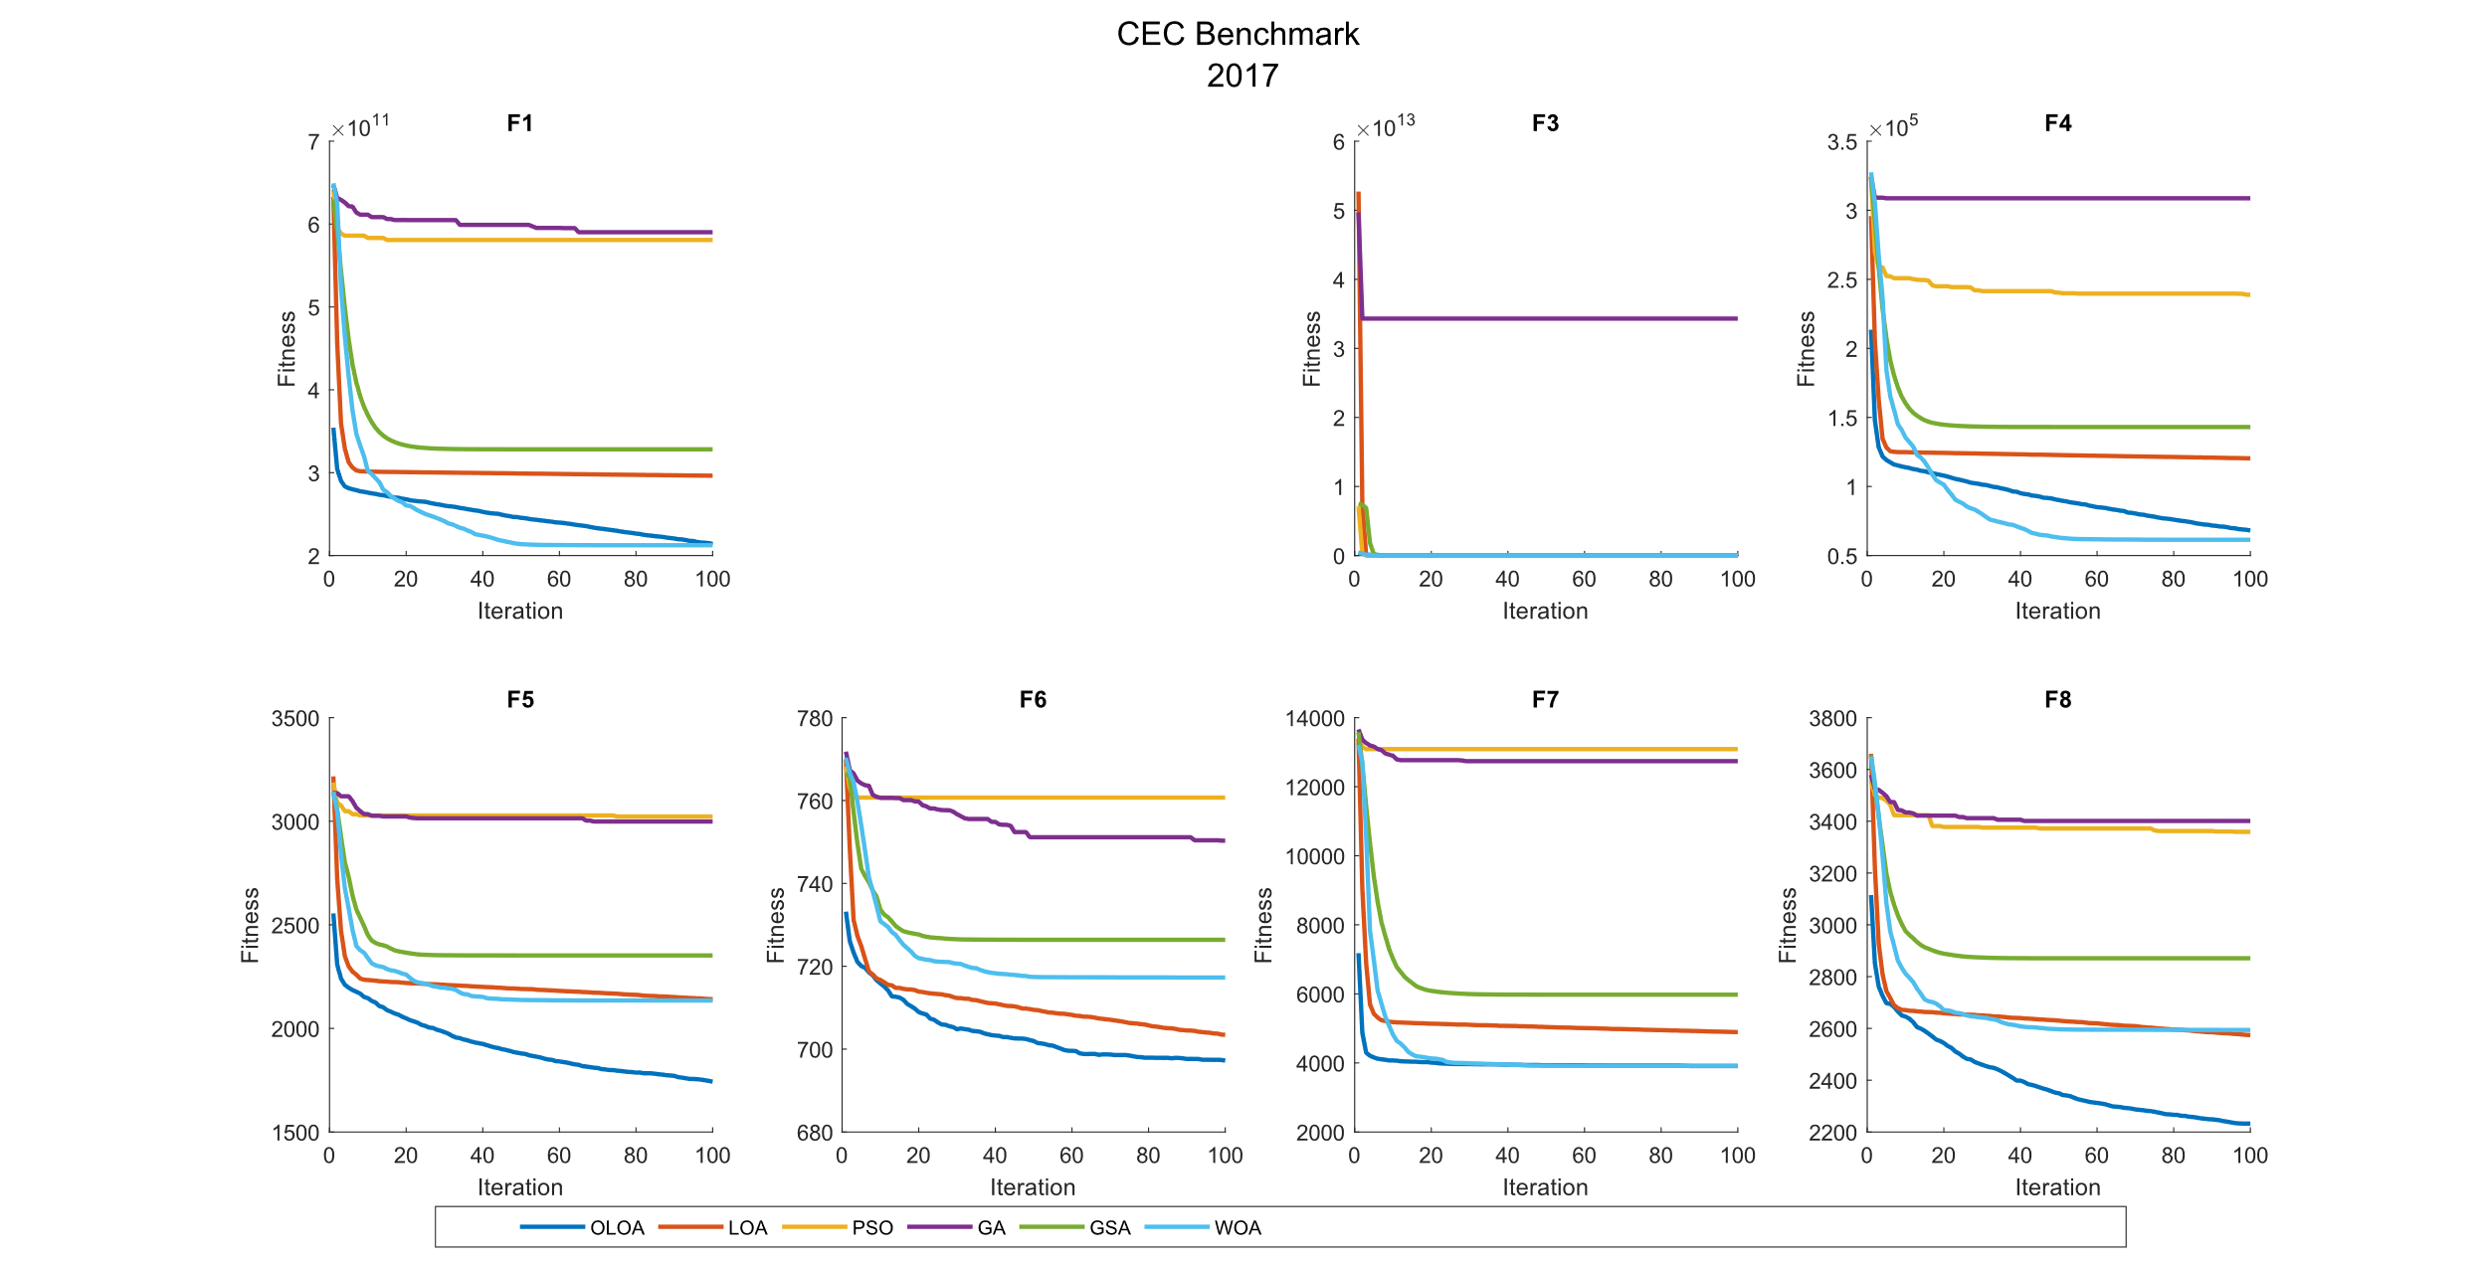 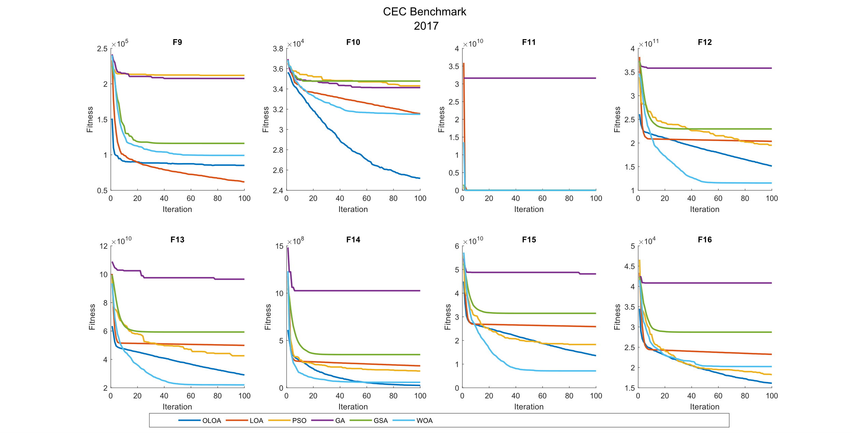 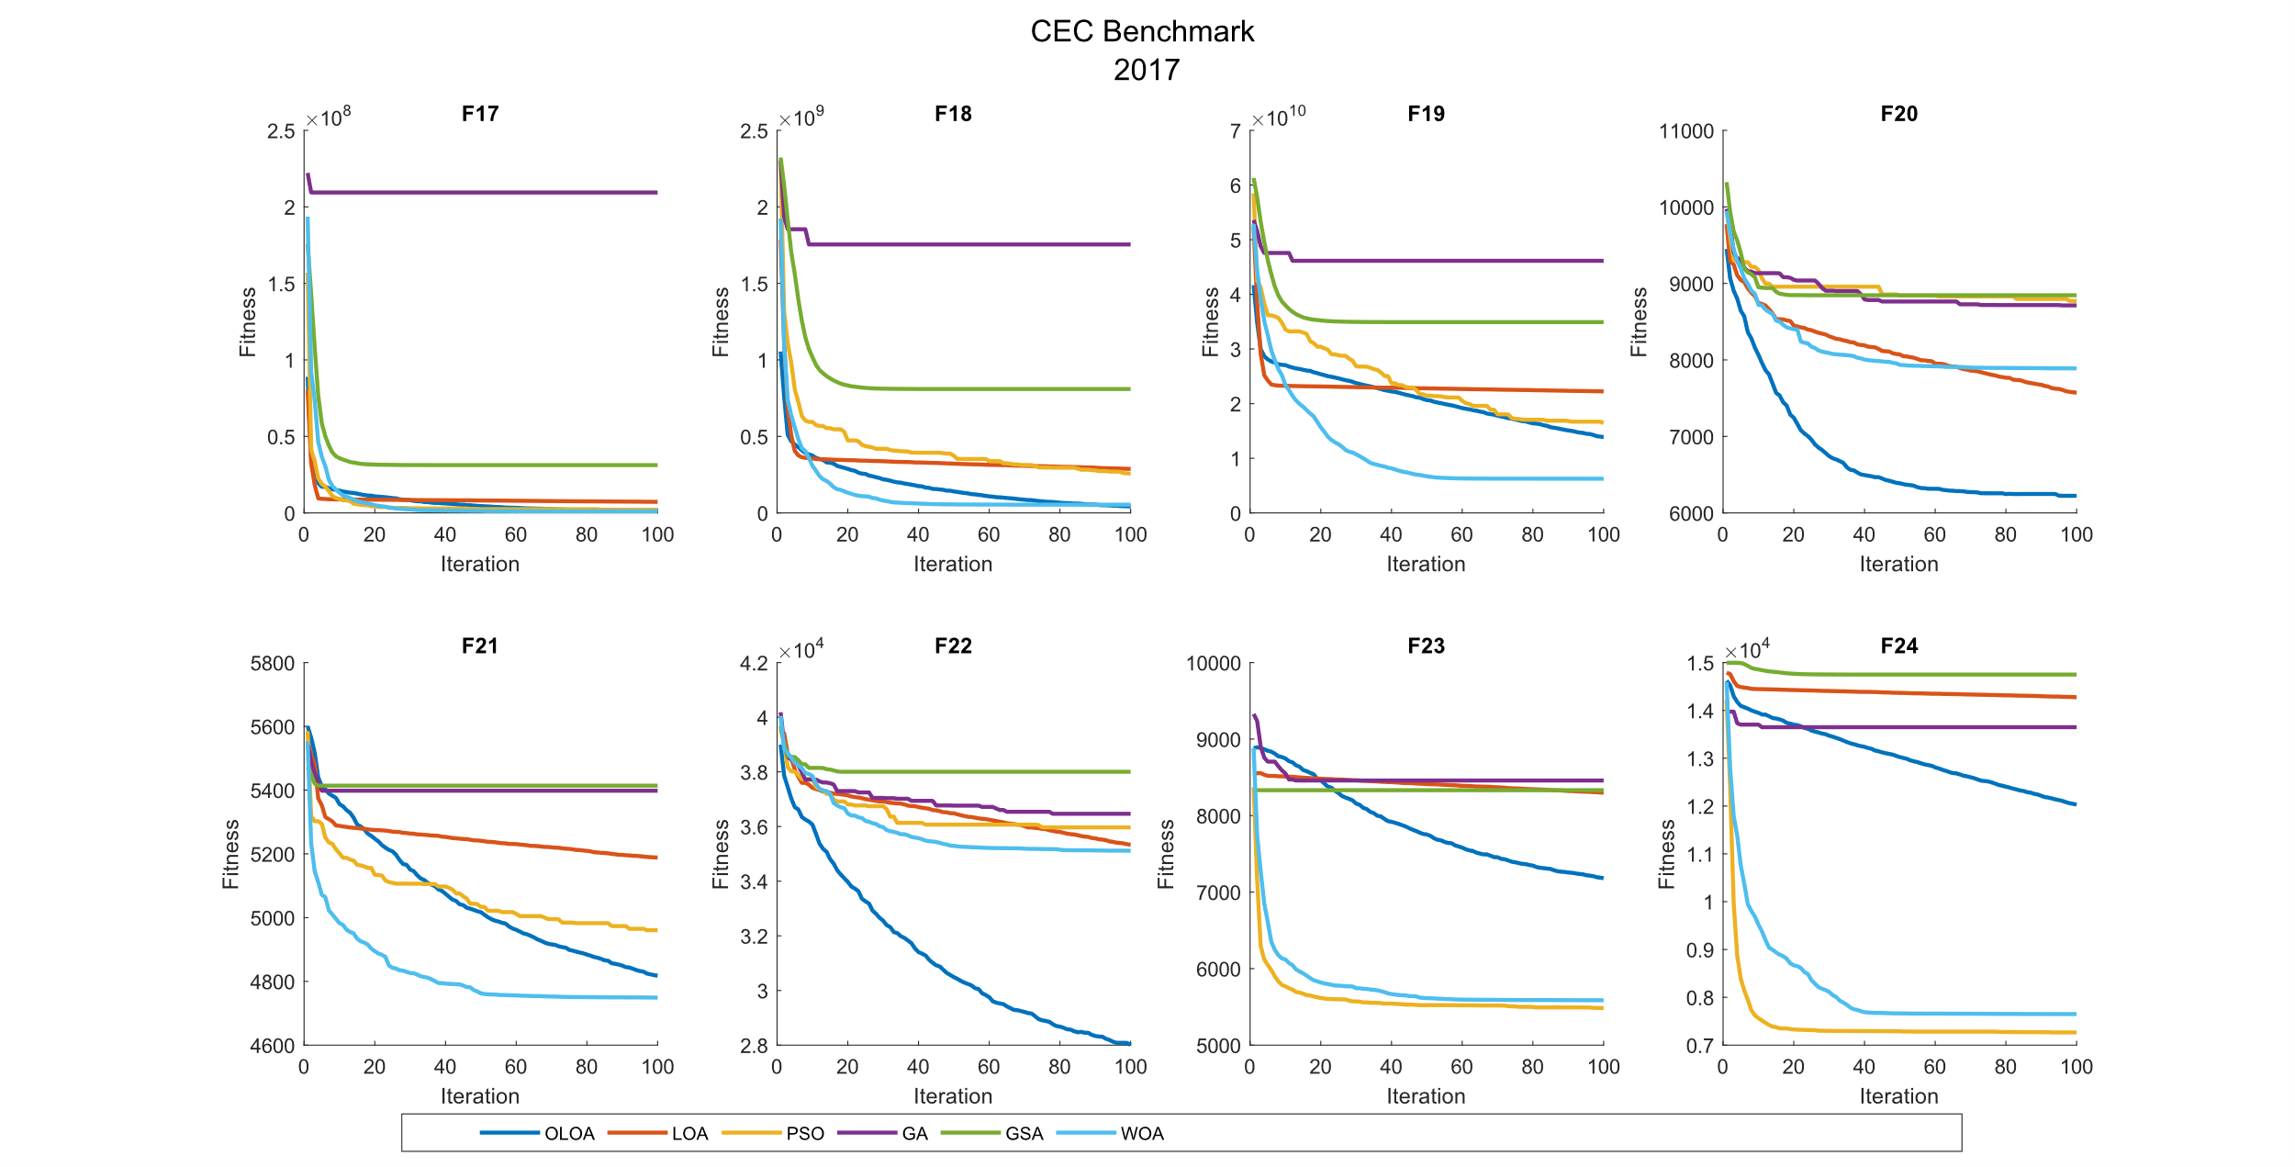 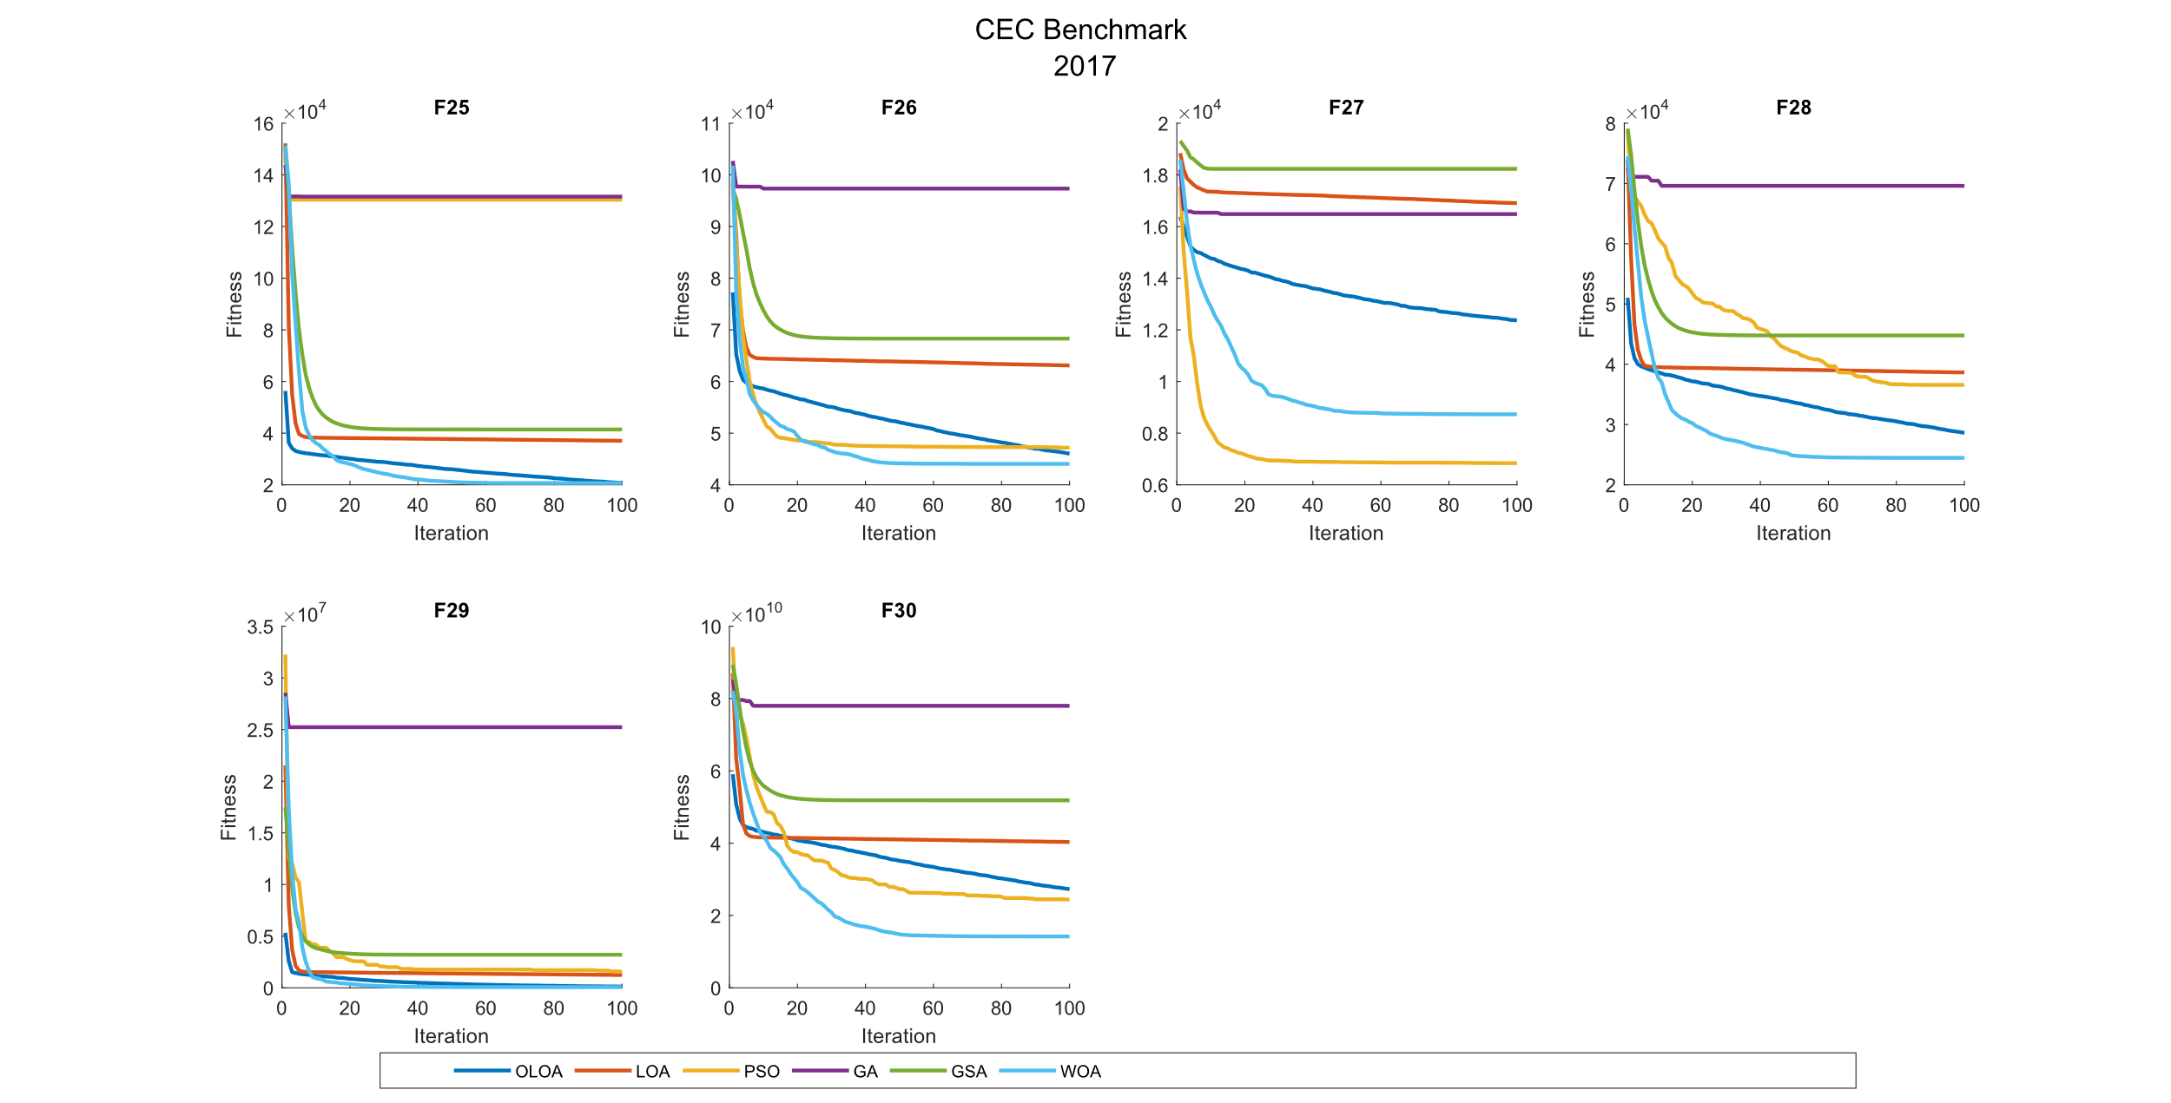

CEC 2022 Benchmark Function 10 Dimensions

|  |  |  |  |  |  |  |  |  |
| --- | --- | --- | --- | --- | --- | --- | --- | --- |
| **Comparison of optimization results for the CEC benchmark functions 2022 (10 Dim)** | | | | | | | | |
|  | Function |  | OLOA | LOA | PSO | GA | GSA | WOA |
|  | F1 | Mean | **8.67E+03** | 1.34E+04 | 3.09E+04 | 1.66E+07 | 3.27E+04 | 3.22E+04 |
|  | Std | 3.49E+03 | 6.02E+03 | 1.24E+04 | 4.53E+07 | 2.18E+04 | 7.25E+03 |
|  | CPU | 0.063 | 0.061 | 0.094 | 0.109 | 0.384 | 0.103 |
|  | F2 | Mean | 7.24E+02 | 2.43E+03 | 6.26E+02 | 3.78E+03 | 3.70E+03 | **5.62E+02** |
|  | Std | 3.09E+02 | 1.40E+03 | 1.51E+02 | 1.27E+03 | 1.24E+03 | 1.24E+02 |
|  | CPU | 0.066 | 0.020 | 0.067 | 0.075 | 0.314 | 0.061 |
|  | F3 | Mean | 6.48E+02 | **6.40E+02** | 6.48E+02 | 6.75E+02 | 6.68E+02 | 6.46E+02 |
|  | Std | 1.13E+01 | 9.58E+00 | 7.69E+00 | 9.18E+00 | 8.27E+00 | 1.83E+01 |
|  | CPU | 0.195 | 0.048 | 0.069 | 0.111 | 0.286 | 0.056 |
|  | F4 | Mean | **8.31E+02** | 8.36E+02 | 8.84E+02 | 8.85E+02 | 8.57E+02 | 8.66E+02 |
|  | Std | 1.04E+01 | 8.72E+00 | 1.35E+01 | 1.75E+01 | 6.92E+00 | 2.03E+01 |
|  | CPU | 0.034 | 0.014 | 0.033 | 0.072 | 0.111 | 0.034 |
|  | F5 | Mean | 1.40E+03 | **1.20E+03** | 2.57E+03 | 4.75E+03 | 1.53E+03 | 1.70E+03 |
|  | Std | 2.53E+02 | 1.74E+02 | 3.88E+02 | 1.19E+03 | 2.57E+02 | 4.71E+02 |
|  | CPU | 0.028 | 0.023 | 0.031 | 0.047 | 0.120 | 0.036 |
|  | F6 | Mean | **1.80E+04** | 4.35E+08 | 1.40E+07 | 1.38E+09 | 9.33E+08 | 2.58E+05 |
|  | Std | 1.64E+04 | 5.08E+08 | 7.46E+06 | 8.72E+08 | 4.70E+08 | 3.69E+05 |
|  | CPU | 0.016 | 0.011 | 0.038 | 0.080 | 0.130 | 0.031 |
|  | F7 | Mean | **2.08E+03** | 2.10E+03 | 2.12E+03 | 2.19E+03 | 2.15E+03 | 2.10E+03 |
|  | Std | 2.18E+01 | 3.26E+01 | 2.19E+01 | 4.68E+01 | 3.52E+01 | 3.71E+01 |
|  | CPU | 0.117 | 0.044 | 0.052 | 0.127 | 0.217 | 0.047 |
|  | F8 | Mean | 2.29E+03 | 2.29E+03 | 2.25E+03 | 2.51E+03 | 2.48E+03 | **2.25E+03** |
|  | Std | 6.43E+01 | 6.62E+01 | 9.32E+00 | 1.52E+02 | 1.44E+02 | 2.27E+01 |
|  | CPU | 0.141 | 0.128 | 0.130 | 0.144 | 0.238 | 0.086 |
|  | F9 | Mean | 2.69E+03 | 2.84E+03 | 2.70E+03 | 3.01E+03 | 2.86E+03 | **2.66E+03** |
|  | Std | 4.04E+01 | 1.44E+02 | 6.95E+01 | 1.42E+02 | 1.20E+02 | 4.88E+01 |
|  | CPU | 0.116 | 0.036 | 0.081 | 0.119 | 0.286 | 0.080 |
|  | F10 | Mean | 2.70E+03 | 2.78E+03 | **2.56E+03** | 2.78E+03 | 3.33E+03 | 2.77E+03 |
|  | Std | 2.07E+02 | 1.64E+02 | 8.69E+01 | 3.58E+02 | 6.20E+02 | 4.50E+02 |
|  | CPU | 0.200 | 0.050 | 0.069 | 0.138 | 0.323 | 0.095 |
|  | F11 | Mean | 3.34E+03 | 3.78E+03 | 3.20E+03 | 4.12E+03 | 4.46E+03 | **3.09E+03** |
|  | Std | 2.74E+02 | 2.57E+02 | 4.81E+02 | 5.19E+02 | 5.28E+02 | 2.85E+02 |
|  | CPU | 0.225 | 0.088 | 0.117 | 0.145 | 0.388 | 0.122 |
|  | F12 | Mean | 3.01E+03 | 3.15E+03 | **2.88E+03** | 3.21E+03 | 3.38E+03 | 2.93E+03 |
|  | Std | 5.21E+01 | 1.03E+02 | 1.78E+01 | 1.29E+02 | 1.94E+02 | 4.69E+01 |
|  | CPU | 0.328 | 0.081 | 0.105 | 0.188 | 0.395 | 0.128 |

|  |  |  |  |  |  |  |
| --- | --- | --- | --- | --- | --- | --- |
| **P-value of the T-test analysis for the CEC benchmark functions 2022 (10 Dim)** | | | | | | |
|  | Function | OLOA versus LOA | OLOA versus PSO | OLOA versus GA | OLOA versus GSA | OLOA versus WOA |
|  | F1 | 4.51E-02 | 3.51E-05 | 2.61E-01 | 2.91E-03 | 2.99E-08 |
|  | F2 | 1.42E-03 | 3.80E-01 | 7.06E-07 | 7.93E-07 | 1.43E-01 |
|  | F3 | 1.03E-01 | 9.43E-01 | 1.57E-05 | 2.57E-04 | 7.07E-01 |
|  | F4 | 2.18E-01 | 9.70E-09 | 1.33E-07 | 2.51E-06 | 1.03E-04 |
|  | F5 | 5.04E-02 | 2.64E-07 | 7.78E-08 | 2.92E-01 | 9.51E-02 |
|  | F6 | 1.44E-02 | 1.32E-05 | 9.02E-05 | 6.30E-06 | 5.48E-02 |
|  | F7 | 2.78E-01 | 1.52E-03 | 3.13E-06 | 1.26E-04 | 1.31E-01 |
|  | F8 | 8.70E-01 | 5.24E-02 | 5.35E-04 | 1.45E-03 | 6.10E-02 |
|  | F9 | 5.77E-03 | 8.56E-01 | 2.24E-06 | 6.02E-04 | 1.42E-01 |
|  | F10 | 3.59E-01 | 6.46E-02 | 5.41E-01 | 6.95E-03 | 6.71E-01 |
|  | F11 | 1.66E-03 | 4.13E-01 | 5.38E-04 | 1.30E-05 | 5.77E-02 |
|  | F12 | 1.07E-03 | 9.05E-07 | 2.12E-04 | 1.79E-05 | 2.10E-03 |

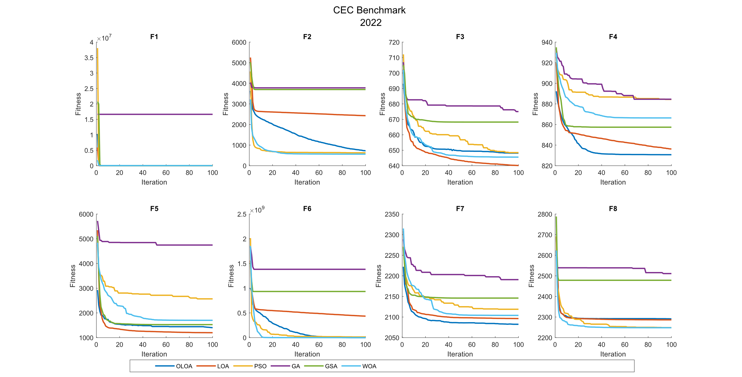 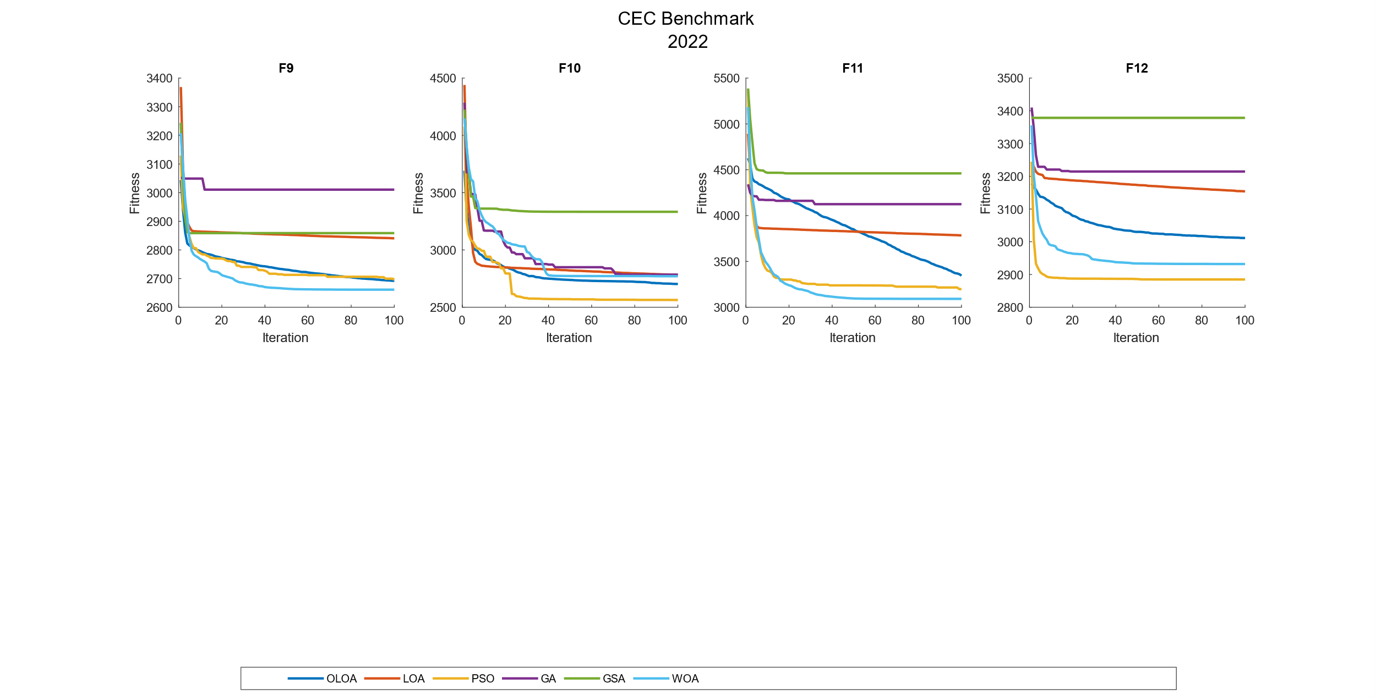

توضیحات الگوریتم و روش کارکرد.

در این الگوریتم از مقاله پایه Opposition Based Learning استفاده شده است که به همراه الگوریتم اصلی LOA ترکیب شده است.

در این الگوریتم از یک تابع متقابل سازی استفاده شده است که در ان از روش ترکیبی Random OBL استفاده کرده ایم.

در هر بار فراخوانی تابع متقابل سازی، یک جمعیت متقابل بر اساس مفهوم عدد متقابل ساخته می شود که از فرمول زیر به دست می آید.

$$OppositePopulation=LB+UB-Population.*rand\left(0,1\right)$$

در این فرمول موقعیت هر عضو در یک عدد تصادفی ضرب می گردد تا انحراف جواب های تولید شده را افزایش دهد و شانس تولید جوابهای متناسب تر بهبود یابد.

در ادامه به ازای دو جمعیت اصلی و متقابل تابع هزینه محاسبه شده و در یک حلقه تکرار به طول جمعیت اصلی بررسی می گردد که ایا مقدار برازش عضو متقابل بهتر از عضو اصلی است یا خیر. در صورتی که عضو متقابل بهتر از عضو اصلی باشد عضو متقابل با عضو اصلی جایگزین شده و در غیر این صورت عضو اصلی بدون تغییر باقی می ماند.

در انتها جمعیت نهایی بر اساس مقدار تابع هزینه مرتب شده و به عنوان خروجی برگردانده می شود.

در الگوریتم اصلی تغییراتی اعمال نشده است فقط در ابتدای هر تکرار الگوریتم تابع متقابل سازی فراخوانی شده و جمعیت برگدانده شده به عنوان جمعیت اصلی در نظر گرفته می شود.

پارامترهای اجرایی الگوریتم  
در این مسئله بهینه سازی با توجه به مقاله اصلی تلاش شده است تعداد از الگوریتم های مرجع مقاله مورد بررسی قرار گیردن ولی با توجه به عدم وجود اطلاعات درست از الگوریتم، کد خروجی برای تابع ارزیابی 2017 کارایی بیان شده را نداشته است.

ولیکن با وجود این مورد، مقادیر استفاده شده در مسئله بهینه سازی تماما مشابه مقاله اصلی است به جز پارامترهای زیر.

$$crossover_rate = 0.8 Crossover rate$$

$$mutation_rate = 0.3 Mutation rate$$

$$sigma = 0.9 Mutation standard deviation$$

پارامترهای اصلی مقایسه نیز مانند الگوریتم اصلی در نظر گرفته شده است و تعداد اجرا 10، بیشترین تعداد تکرار 100 و تعداد متغیر های تصمیم برای ایجاد یک تفاوت معنا دار در نتایج 30 گرفته شده است.